

Group Design and Integration Project UFMFV8-15-3

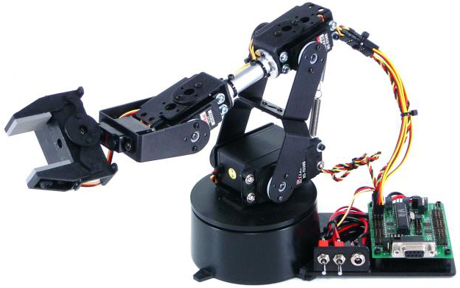

Team Members

- Chris Leddington (23055365)
- Alex Winterbottom
- Charlie Shepherd
- Noah Sachs
- Solomon Roberts

Word Count:

Table of Contents
Table of Contents 3
Table of Figures 5
1. Introduction – few paragraphs max 300 – 400 words (Charlie) 6
1.1. Background 6
1.2. Project Scenario & Application 6
1.3. Aims and Objectives 6
1.4. Scope of the System 6
2. 2. Project Management 7
2.1. Team Structure & Roles *only include in submitted files not in report* (Chris) 7
2.2. Planning Approach (Chris) – complete waiting review 7
2.3. Work Breakdown Structure (WBS) (Chris) 7
2.4. Gantt Chart *MS Projects Required for connecting arrows* (Chris) 8
2.5. Task Allocation (Chris) 9
2.6. Progress Monitoring (Noah) 11
2.7. Risk Management and Safety Requirements (Charlie) 11
2.8. Coordination & Collaboration (Charlie) 12
3. Requirements Analysis 14
3.1. Business Case & Market Justification (Solomon) 14
3.2. Stakeholder Identification * Appendix keep short for now just a list and matrix* 14
3.3. Requirements Document Structure 15
3.4. Stakeholder Needs 15
3.5. Needs into Requirements 16
3.6. Stakeholder requirements 16
3.7. System and Sub System requirements 16
4. Design and Implementation (all) 19
4.1. Top-level System Design 19
4.1.1. Mechanical 20
4.1.1.1. Sequence Diagram (Charlie) 20
4.1.1.2. Initial Sketches (Noah) 20
4.1.1.3. CAD Models and Drawing (Chris ) 21
4.1.2. Software 23
4.1.3. Electrical 23
4.2. High-level Design 23
4.2.1. Mechanical 23
4.2.1.1. Sub-system Flow Chart (Case Diagram) Chris 24
4.2.2. Software 24
4.2.3. Electrical (only required in top/high-level design) 25
4.3. Low-level Design 26
4.3.1. Mechanical 26
4.3.1.1. Replacement Arm 26
CAD Model 26
Analysis 26
4.3.1.2. Forks 27
Design Development 27
CAD Model 27
Analysis 29
4.3.1.3. Pallet 30
Design Development 30
CAD Model and Drawing 31
Analysis 36
4.3.1.4. Storage Rack 36
CAD Model 36
Analysis 37
4.3.1.5. Assembly Table 38
CAD Model 38
Analysis 38
4.3.2. Software 39
5. Verification & Validation Planning (Noah) 40
5.1. V&V Strategy 40
5.2. Verification Methods 40
5.3. Validation Methods 40
5.4. V&V Matrix Overview 41
5.5. Regulatory Considerations 41
6. References 49
7. Appendices 50
7.1. Risk Management and Safety Requirements 50
7.2. Stakeholder Analysis 52
7.3. Collaboration and Communication 53
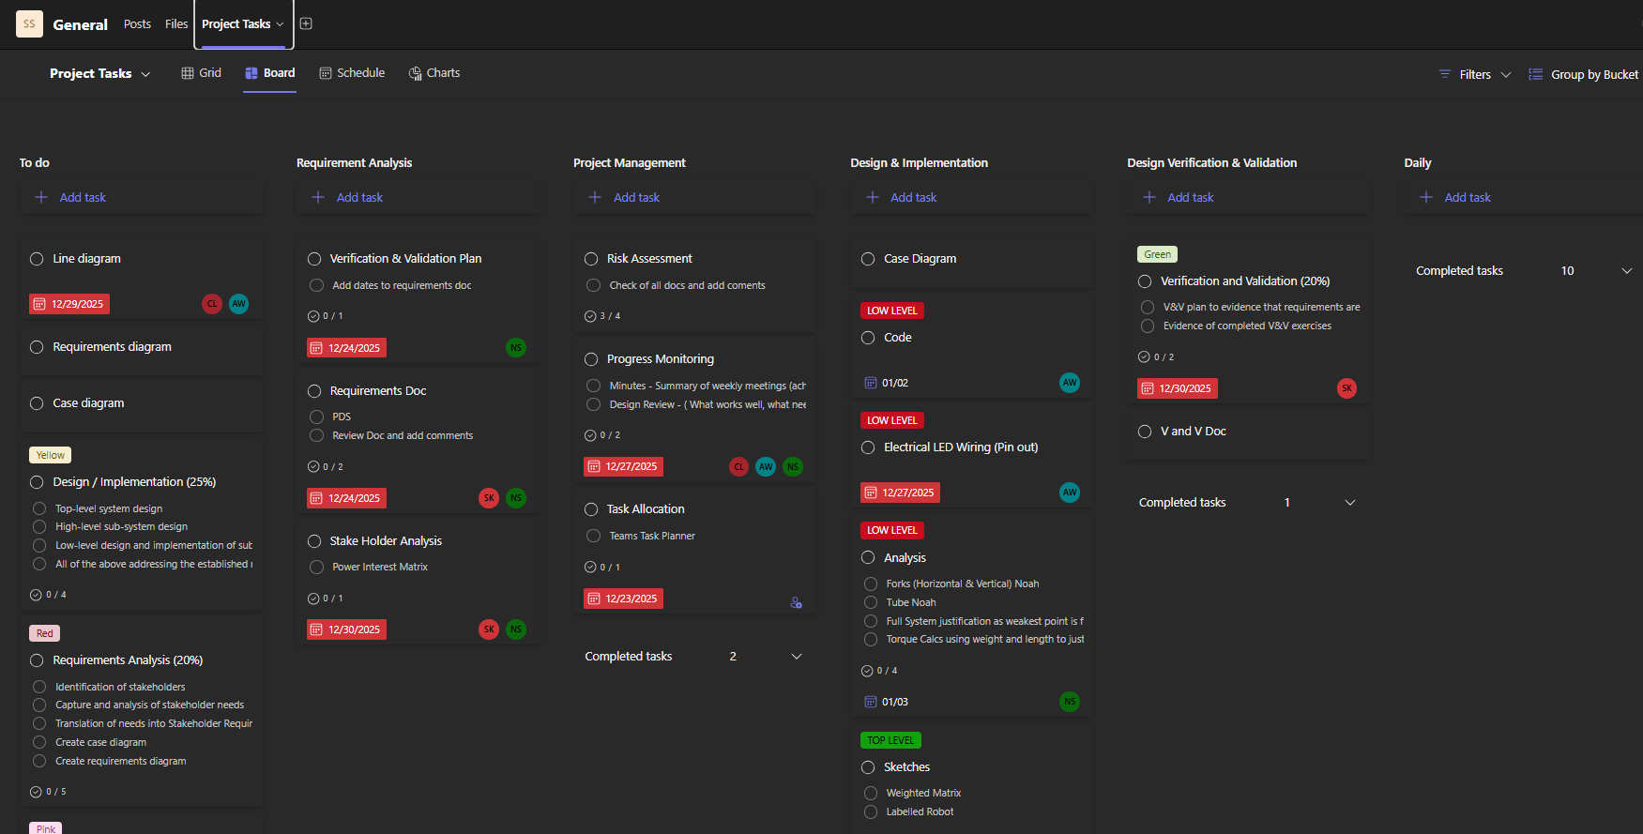 53

Table of Figures
Figure 1 - United Nations Sustainable Development Goals 3
Figure 2 - UWE Innovation & Design Thinking Toolkit 5
Figure 3 - Discovery Diagram 5
Figure 4 - Stakeholder Map 6
Figure 5 - Idea Generation 7
Figure 6 - Idea Decision Matrix 8
Figure 7 - Final Design CAD Model 8
Figure 8 - Risk Management Table 9

Introduction – few paragraphs max 300 – 400 words (Charlie)

Background
For the project, our group was tasked with the design, implementation, and evaluation of a ‘pick and place’ system using a robot arm that can be trained to repeatedly move an item from one location to another. We have been provided with a Lynxmotion AL5D robot arm as a base platform and required to develop our own control system as well as adapting mechanical components as appropriate to meet our project requirements. The group has derived the system requirements for our chosen application of a burger assembly system. It is key to note that the group was provided with a different Lynxmotion robot (AL5B) that features a smaller working envelope and reduced motor capacity compared to the standard AL5D model, provided to all other groups. While the original AL5D arm offers a reach of 50cm, our arms reach is significantly smaller (33.5cm) and is a limitation confirmed by the lecturer.

Project Scenario & Application
The application for our robotic arm is to develop a system capable of automating the burger assembly process. With the use of the Lynxmotion AL5B robotic arm as a base platform, the system is designed to execute pick and place operations, enabling the robotic arm to select individual burger components and assemble them in the required order. Our application aims to demonstrate how robotics can improve the operational efficiency and product consistency while then reducing the reliance on manual labour where there are more room for errors. The application will showcase the feasibility of integrating robotics into food preparation workflows.

Aims and Objectives
The aims and objectives of our robot arm application have been detailed below.
Aims:
- To have a working robot that can assemble a burger.
- Reducing the assembly time in comparison to manual processes.
- Reducing human error in the process of burger assembly.
- Developing a practical and intuitive control interface.
Objectives:
- To develop a system for the robot arm to perform a precise ‘pick and place’ operation specific to our application.
- Adapt the mechanical components as necessary to handle burger ingredients safely and effectively.
- Define the positioning and sequence for assembling a burger.
- Design an easy-to-use interface for controlling the robot that includes a ‘teach’ mode.
- Validate the system against the defined performance parameters.

Scope of the System
The robot is designed to pick and place the burger components, including the burger patty and 2 no. buns. All components will be placed in fixed predefined locations for repeatability and ease of the user interface. The burger will not be required to assemble sources to the burger. The ingredients are pre-prepared, and no cooking is included in the process.

2. Project Management

Team Structure & Roles *only include in submitted files not in report* (Chris)
Describe each member’s role and why responsibilities were assigned this way.
Group Member | Member Role
Chris Leddington | Project Management/Mechanical Design
Alex Winterbottom | Software/Electronic Design
Charlie Shepherd | Systems Design
Noah Sachs | Mechanical Design
Solomon Kembery | System Design

Planning Approach (Chris) – complete waiting review
Planning of the project was focused on effective task allocation based on individual skill sets, setting achievable time goals, and maintaining a transparent plan that all team members could access and contribute to. This approach was essential in ensuring that effort was directed towards the most critical areas of the project at the appropriate stages of development, maximising efficiency and reducing unnecessary rework.

Planning was carried out iteratively, allowing the team to adapt to design changes and practical constraints encountered during development. Early planning prioritised understanding system requirements and identifying key technical challenges, particularly those associated with handling food items of varying size and compliance.

Overall, the planning approach provided a flexible yet structured framework that supported steady progress and effective integration of all system elements.

Work Breakdown Structure (WBS) (Chris)
The first stage of detailed planning for the project was the creation of a Work Breakdown Structure (WBS). This was used to organise the project into manageable activities and ensure that all required work was identified early. The project was divided into four main phases: planning and requirements, design, implementation, and testing and evaluation.
Breaking the project down in this way made it easier to group related tasks and understand how different activities linked together. The WBS provided a clear overview of the project and was later used to support task allocation and scheduling.
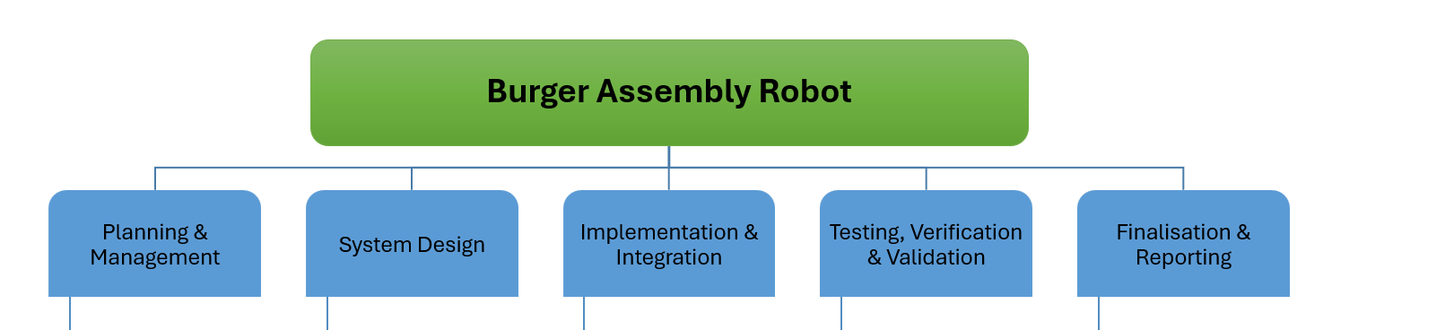

Gantt Chart *MS Projects Required for connecting arrows* (Chris)
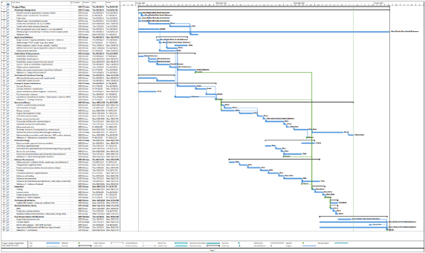
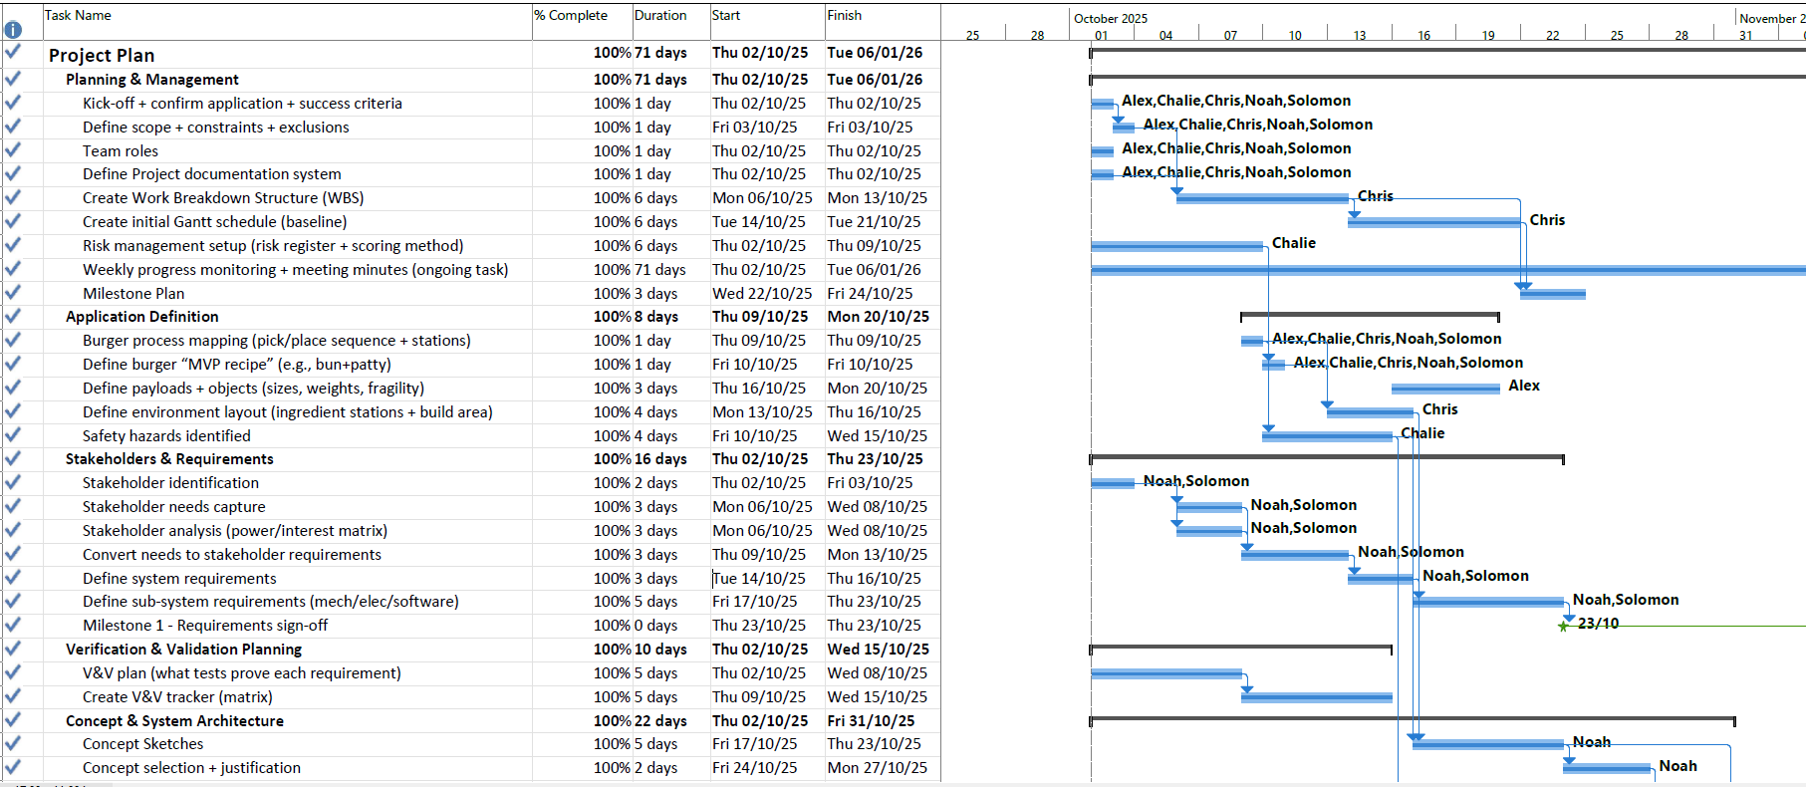
The Gantt chart was developed using Microsoft Project and provided a clear visual representation of the project timeline, including task durations, dependencies, and key milestones. Tasks included in the Gantt chart were derived directly from the Work Breakdown Structure (WBS), ensuring consistency between project planning and scheduling.

The project was structured into sequential phases, beginning with planning and system design, followed by implementation, integration, and testing, before concluding with finalisation and reporting activities. Task dependencies were included in the Gantt chart to ensure prerequisite activities, such as application definition and requirements related tasks, were completed prior to commencing the concept design. Considering these dependencies helped prioritise tasks and ensured that all required information was available before progressing to the subsequent stages. Without this approach, there would have been an increased risk of rework resulting from late design changes.
The Gantt chart was used as a live planning tool throughout the project and was reviewed regularly during team meetings to monitor progress. In some instances, practical constraints and delays were identified, requiring adjustments to task durations and start dates. When the Gantt chart was initially created, conservative estimates were used for task durations, as will all estimated the accuracy of these estimates varied and some tasks were completed earlier than expected, while others required additional time. Time gained from early task completion provided useful slack within the schedule, allowing delays to be absorbed without impacting the overall project completion date.

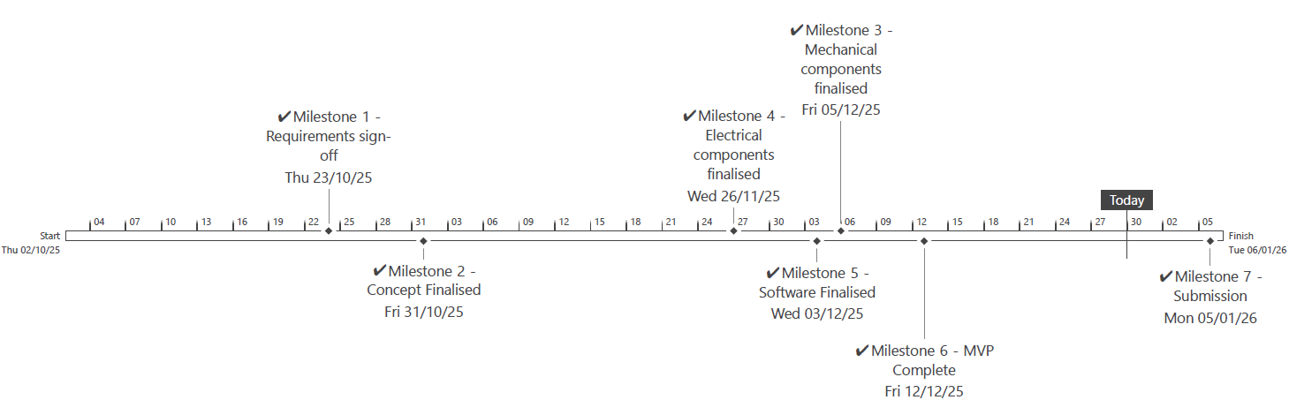
Milestones were defined at the end of each major project stage and are represented by green stars on the Gantt chart. These milestones acted as stage gates, providing formal review points to ensure each phase was sufficiently completed before progressing. This gated approach proved effective for a design-focused project, helping the team maintain focus and control as the project advanced.

Task Allocation (Chris)
The Gantt chart aligned when each tasks needed to be carried out, combining this with the skills matrix informed the task allocation. Tasks were listed in a Microsoft Teams Chanel and assigned to each team member. We gave a task description and deadline and reviewed the tasks list during catch up meetings. This worked well to cover progress, highlight any blockers on progress and create rectification plans if deadlines began to slip.
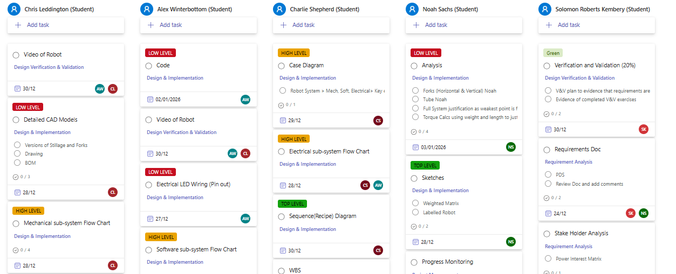

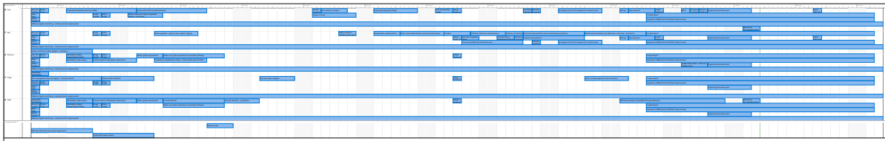
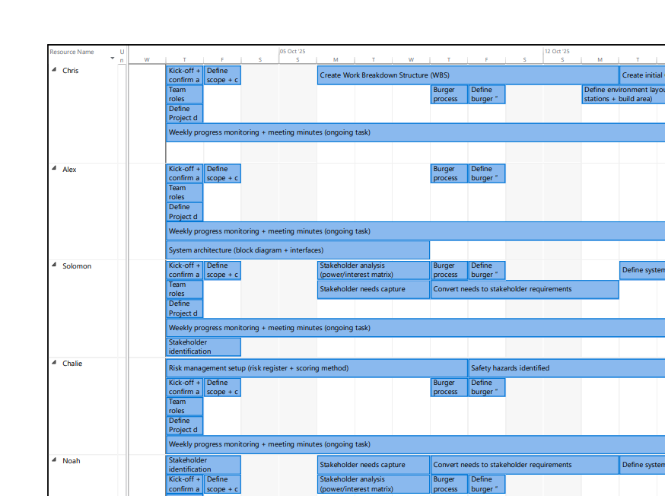

Progress Monitoring (Noah)
Explain how you tracked progress (meetings, reviews, updates).
Weekly meeting minutes
Progress Reviews to assess robot automation
Target dates set to achieve

Risk Management and Safety Requirements (Charlie)
Risk management is essential for any project to ensure reliability, safety, and on-time completion of the robot arm application/design. The risks associated with the project were identified in 3 main areas: Project Management, Health & Safety (H&S), and Design and Functional risks of individual parts. The risks identified for each category were monitored and mitigated throughout the project’s lifecycle using appropriate tools.
For the H&S, a risk assessment was created to identify the hazards associated with robot in operation. The document used a risk matrix to generate a risk level for each hazard, see Table 1 - H&S Risk Matrix. The initial risk level is calculated by multiplying the S and L together based on the existing control measures, additional control measures were then implemented to reduce the risk level. The aim for all our hazards was to have them within negligible (1 – 2) or tolerable (3 – 5) action level as indicated by the ‘Action Level’ matrix, see Table 3 - Action Level Matrix.
Select H&S risks that the group identified and that are included in the risk assessment have been provided below, along with how they were monitored and mitigated. The risk assessment also includes whom and when the control measures are implemented, and the date completed.
- Hazard: cleaning agents used to clean the gripper may leave residues or be mishandled. Existing control measures: food-safe cleaning agents will be used, and all staff will be COSHH trained. Additional control measures: Surfaces will be rinsed after cleaning gripper, and staff will be provided with the appropriate PPE to complete the cleaning process.
- Hazard: Persons working near the robot may be injured due to unexpected movement or lack of awareness. Existing control measures: all staff will need to complete safety training and signage will be installed around the operating area of the robot. Additional control measures: Risk assessments will be conducted and all staff provided with appropriate PPE.
The group also created a risk assessment for the project management risks associated with the robot application; the risk matrix was changed to align with the project management hazards identified to ensure the risk level and action levels were accurate to the hazards identified, see Table 2 - PM Risk Matrix.
Select project management risks that the group identified and that are included in the risk assessment have been provided below, along with how they were monitored and mitigated. The risk assessment also includes whom and when the control measures are implemented, and the date completed.
- Hazard: budget overruns. Existing control measures: cost estimation during project planning.
Regular finance reviews to understand monthly or quarterly budget tracking and reporting. Additional control measures: cost breakdown structures, real-time budget monitoring, independent financial audit.
- Hazard: Loss of design documentation. Existing control measures: Microsoft Teams site created where all design documents are uploaded and saved. Additional control measures: templates of design documentation to be uploaded to the team's site before starting any work. Clear evidence of document revisions. Edit documents on the live versions to that work is constantly saved.

To ensure reliability of the robot arm, the group created a Design Failure Mode, Effects, and Critically Analysis (DFMECA) for the individual components of the robot to meet safety requirements, see Table 4 - DFMECA.
The DFMECA ensured that the group identified, in its existing state, potential failure modes for individual components of the robot, the potential effects of failure associated with the failure mode, potential causes of failures, and the design verification. Remedies are then proposed to reduce the severity, occurrence, detection through recommended actions, the individuals responsible and the completion date, and then finally the actions taken. By doing this, a Risk Priority Number (RPN) is then calculated and indicates which failure modes should be prioritised. The potential failure modes with the highest RPN were prioritised by the group and actioned quicker than others. An example from the DFMECA has been provided below.
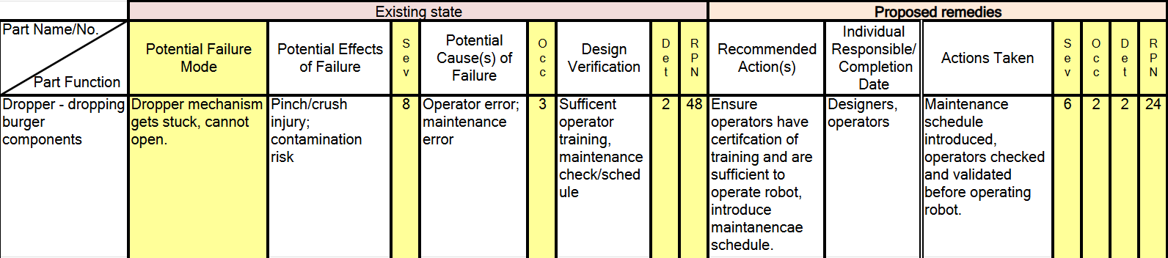
Figure 1 - DFMECA Example

Coordination & Collaboration (Charlie)
Our group set up a dedicated Microsoft Teams site for out project with all the members added to the group, this enabled us to centralise the project communication and keep work accessible. The Teams group served as a single workspace for:
- Files – All our documentation, CAD exports, sketches, validation videos etc, were uploaded to this single site to ensure that no progress was lost and documents could be located easily and viewed by all group members.
- Tasks Planner – The group utilised the ‘Task Planner’ function on Teams and allocated each member of the group their relevant tasks associated with the work they have completed on the project to date, including the essential documentation for the project, see Figure 2 - Task Allocation in the appendices. Tasks such as creation of Gantt Chart, mechanical analysis, requirements, were assigned to group members. We also ensured that the tasks allocation was evenly split and each one given a timescale for completion.
- Communication – As a group we scheduled multiple online Teams meetings to ensure that we were keeping on top of the work required and to make sure that it aligned with our Gantt Chart schedule. These meetings would consist of progress updates, any issues/blockers, and further actions required with set deadlines. Posts would be submitted on the main feed of the Teams site for all group members to see, these would usually be to ask questions within our group, provide documentation like CAD files for the FEA analysis, or to update members of the group on availability.
- Collaboration – The Teams site allows multiples members of the group to edit a document at the same time, ensuring time efficiency.
The group decided to use Teams due to its reduction in context switching (chat, files, tasks, meetings) and provided a single location for the project.
The documentation strategy was to upload all WIP documents to the Teams site for all group members to view or edit. The documents ‘owner’ would then create a final version when all edits/updates had been made to said documents. This allowed for Work In Progress (WIP) documents to be continuously saved to the cloud when making edits, this ensured no loss of work. Review comments were also utilised to aid coordination within the group; these comments could be ‘assigned’ within the documents and ‘resolved’ once the comment had been closed out.

Requirements Analysis

Business Case & Market Justification (Solomon)
This product can automate burger assembly. With a small, table mounted robot, it's possible to reduce reliance on manual labour, along with the inherent factors human operation implies. For example, space, space for walking and working, heavily regulated and costly considering the footprint these considerations consume. With our product, production spaces (kitchens) can be drastically reduced saving businesses money and provide logistical advantages as they no longer need to consider the needs of people in that area. This robot arm improves efficiency and constancy of assembly, and the benefits are two-fold. Firstly, an increased max production rate, and secondly, increased consistency of the finished product. This not only increases potential profit margins, related to faster production, or reduced peak-time queuing, but also increases predictably of production, losses like spillages, and capacity to calculate machine availability.

Stakeholder Identification * Appendix keep short for now just a list and matrix*
Early in the project, stakeholders were identified to ensure the burger assembly robot was developed around the user’s needs, market expectations, and safety constraints.
Stakeholders were selected based on who would purchase, operate, maintain and be affected by safety of the system. For the burger assembly application, the key stakeholder groups identified were:
- Operators (kitchen/production staff): interact with the system during setup, teaching, and daily use, and are directly affected by usability, speed, reliability, and safety.
- Shift supervisor/manager: responsible for throughput, quality, compliance, and ensuring the station runs efficiently with clear status/fault indication.
- Business owner/buyer (customer organisation): concerned with cost, return on investment, maintainability, footprint, and integration into existing workflows.
- End customer (food consumer): indirectly impacted through product consistency, hygiene expectations, and perceived safety of robotic food preparation.
- Maintenance/engineering support: responsible for diagnosing faults, servicing components, and minimising downtime through clear documentation and accessible design.
- Regulatory and safety stakeholders (food hygiene and workplace safety): influence requirements for safe operation, risk controls, and hygiene practices appropriate to a food-handling environment.
- Development team (project team): internal stakeholders who must deliver a feasible design within time and budget constraints, while meeting the module’s functional requirements such as teach mode, teleoperation, working envelope, and status signalling.
These stakeholder groups were then prioritised using a power/interest matrix to decide who needed the most prioritisation during requirements capture and validation. Operators and supervisors were treated as high-priority stakeholders due to their direct interaction with the robot and influence on acceptance, while buyers and regulatory/safety stakeholders were critical for commercial viability and compliance.

Requirements Document Structure
Requirements were managed using a single Excel-based requirements document to maintain clear traceability from early stakeholder needs through to detailed design decisions and verification evidence. Stakeholder needs, stakeholder requirements, system requirements, and sub-system requirements were all contained within the same workbook, allowing needs to be systematically decomposed into lower-level requirements and ensuring that all aspects of the system were fully captured.
Verification was embedded directly within the same document, with each sub-system requirement assigned a defined verification method, pass criteria, and evidence reference. Integrating verification and validation (V&V) into the requirements structure reduced the risk of document-control errors and made it easier to follow the flow of each requirement from origin through to verification. This approach was selected to support the final V&V process and to provide clear evidence that the system met all defined requirements.

Stakeholder Needs
Stakeholder needs were captured to ensure the burger-assembly application was driven by operational expectations such as usability, throughput, hygiene and reliability. The needs also encompassed the technical constraints of the project that influenced the mechanical and electrical changes that needed to be made to the robot system. The needs focused on identifying what must be proven to work to demonstrate credible core functionality and user value to have a minimum viable product (MVP).

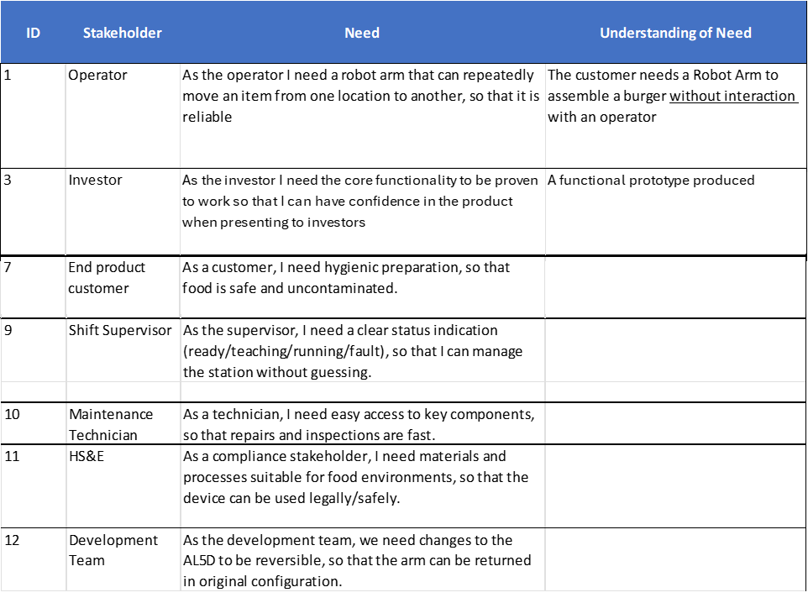

Needs into Requirements
To generate a complete and realistic set of requirements for the burger assembly robot, a combined top-down and bottom-up approach was used. Using both methods reduced the risk of missing either high-level constraints or practical operational issues that only become obvious when considering real use of the system.
- Top-down: requirements were first drawn from the technical constraints and expected MVP functionality, for example the system having a teach mode and the need for status/error signalling. These were then expanded further to create system and sub-system requirements.
- Bottom-up: The bottom-up approach started from how the robot would be used in a burger assembly context and built requirements from operational realities, user interactions, and failure modes. By considering tasks such as teaching pick locations, repeatedly stacking components, and recovering from faults, additional usability, reliability, and safety-related requirements were identified. This ensured the final requirements set reflected both the intended application and the practical constraints of operating the system.
Using this combined approach, stakeholder needs were systematically converted into stakeholder requirements and then broke down into system and sub-system requirements, as outlined in the following sections.

Stakeholder requirements
Stakeholder requirements were derived by translating stakeholder needs into clear, testable “shall” statements that define what the system must achieve to satisfy each stakeholder. This step was necessary to remove ambiguity from the needs, such as ease of use or reliability, and to ensure each requirement could later be verified.
Stakeholder requirements focus on what the system must deliver from the perspective of each stakeholder group, without specifying implementation details. For example, operator needs for adaptability and safety were translated into requirements relating to teach mode functionality and safe remote operation, while supervisor needs were translated into requirements for clear system state indication.
These stakeholder requirements provided the basis for defining the overall system behaviour and constraints.

System and Sub System requirements
System requirements were developed by expanding stakeholder requirements into functional and non-functional requirements that describe the behaviour of the complete burger assembly robot. These requirements define how the system operates as a whole and ensure compliance with both stakeholder expectations and the projects technical constraints.
System requirements include core functionality such as pick-and-place operation, teach mode and system state management. Each system requirement was written to be measurable and was assigned a verification method to ensure it could be objectively assessed during testing.
Sub-system requirements were derived by allocating system requirements to the mechanical, electronics, software, safety, quality and management sub-systems. This expansion ensured that each sub-system had clearly defined objectives and that design and implementation tasks could be carried out in parallel while maintaining traceability.
Mechanical sub-system requirements focused on aspects such as deflection and interaction with the burger assembly environment. Electronics requirements addressed control hardware, power distribution, and system outputs, while software requirements focused on user interaction, teach mode logic, state control, and safety behaviour.
System requirements were developed by expanding stakeholder requirements into functional and non-functional requirements that describe the behaviour of the complete burger assembly robot. These requirements define how the system operates as a whole and ensure compliance with both stakeholder expectations and the project’s technical constraints. System requirements include core functionality such as reliable pick-and-place operation, teach mode capability, and system state management. For example, the workbook captures system-level requirements relating to predictable control behaviour (e.g., SR 1.1.1 covering calibration/consistent coordinate mapping), teach mode execution (SR 2.1.1), and defined LED status indication for system states (SR 9.1.1, specifying READY/TEACHING/RUNNING/FAULT behaviour). Each system requirement was written to be measurable and was assigned a verification method in the requirements document to ensure it could be objectively assessed during testing.

Sub-system requirements were derived by allocating system requirements to the mechanical, electronics, software, safety, quality and management sub-systems. This expansion ensured that each sub-system had clearly defined objectives and that design and implementation tasks could be carried out in parallel while maintaining traceability back to stakeholder needs through the ID structure. At sub-system level, each requirement includes a planned verification method, pass criteria and an evidence/reference field to support V&V close-out (e.g., Test, Inspection, Document Review, or FEA). For example, the teach-mode system requirement is decomposed into implementable software/HMI requirements such as SSR 2.1.1.2 (waypoint list with add/remove, verified by Test), while structural performance is captured through mechanical requirements such as SSR 3.1.3.3 (arm tip deflection limited to ≤ 5 mm, verified by FEA). Hygiene and process controls are captured through HS&E/quality requirements such as SSR 7.1.2.1 (cleaning checklist, verified by Document Review), demonstrating that non-functional requirements were treated alongside functional behaviour.

Mechanical sub-system requirements focused on aspects such as deflection and interaction with the burger assembly environment. Electronics requirements addressed control hardware, power distribution, and system outputs (including status/fault indication), while software requirements focused on user interaction, teach mode logic, state control, and safety behaviour.

3.3 Stakeholder Needs * Potentially Remove * (Solomon)
Complete requirements excel on first

Start to summarise use example report for guidance. Pick specific requirements and talk about it
Describe what each stakeholder needs from the system.

3.4 Stakeholder Requirements
Convert needs into clear, testable requirements.

3.5 System Requirements
Define high-level system behaviours and performance requirements.

3.6 Sub-System Requirements
Break system requirements into mechanical, software, and electrical requirements.

3.7 Requirements Traceability *Mention but no figure* (evidenced in requirements template)
Explain how requirements link from stakeholder → system → subsystem → V&V.

Design and Implementation (all)
From mark scheme*
This section documents how the burger-assembly pick-and-place concept was implemented as a complete prototype system. To keep the design defensible and traceable, development was structured into milestone gates (requirements sign-off, concept selection, electrical/software/mechanical finalisation, integration and verification/validation). The same milestone structure is used here to present a chronological engineering narrative: requirements drove concept selection; concept selection drove subsystem implementation; integration exposed cross-domain issues that were resolved through iteration and then verified through repeatable test evidence.
The system was intentionally scoped as an assembly/stacking demonstrator (pre-prepared ingredients placed at fixed stations), rather than a full end-to-end food automation line. This allowed effort to focus on repeatable, accurate placement and operator usability within the constraints of the supplied Lynxmotion AL5B platform (limited reach and payload, and a requirement to avoid destructive or irreversible hardware modifications).

Clear presentation of top-level system design. Clear presentation of high-level design of the main subsystems (e.g. software, electronics). System and sub-system design efficiently and effectively address all relevant requirements. Design documentation is accessible and easily interpreted.

Top-level System Design
At top level, the prototype comprises three interacting subsystems: (1) a mechanical handling environment (pallets, forks, storage rack and assembly table), (2) an electrical indication layer (status LEDs and power distribution using the existing robot controller), and (3) a software control system providing calibration, teleoperation and teach/execution workflows. Together these enable an operator to define a burger assembly routine and replay it consistently.
Major system elements are summarised below:
Robot arm: Lynxmotion AL5B with standard servo-driven joints and gripper.
End-effector tooling: bolt-on forks that interface with the pallet mechanism.
Pallet/stillage: holds a burger component and releases it by opening sliding jaws to drop at a defined location.
Ingredient stations: storage rack/shelves that hold pallets at repeatable pickup points.
Assembly table: drop zone with a self-centering guide feature to improve repeatability of stacking.
Control software (PC): operator UI for calibration, teleop, teach mode, routines and timeline execution.
Electrical indication: 6-LED scheme (industrial traffic-light + power/teach/comms indicators) driven via available controller outputs.

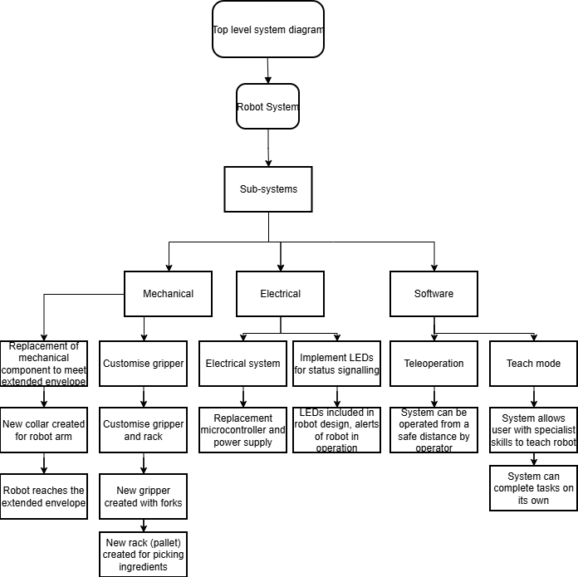

Mechanical
The mechanical system was designed around a palletised drop concept. Each burger component is placed into a dedicated pallet and stored at a fixed station. The robot retrieves the pallet using fork tooling, moves to the assembly table, actuates the pallet to release the ingredient, and then returns the pallet to its station. Repeatability is achieved through: fixed station geometry, tapered/chamfered guiding features to tolerate minor positioning error, and a self-centering guide at the assembly drop point.
The concept avoids relying on friction-driven sliding of food items (e.g., tipping) because this was assessed as inconsistent for repeatable placement. Instead, the pallet releases the component by opening a controlled aperture so the ingredient drops under gravity into the guided drop zone.

Sequence Diagram (Charlie)

Sequence of making the burger. All aspects of burger what is in scope and out of scope for this project

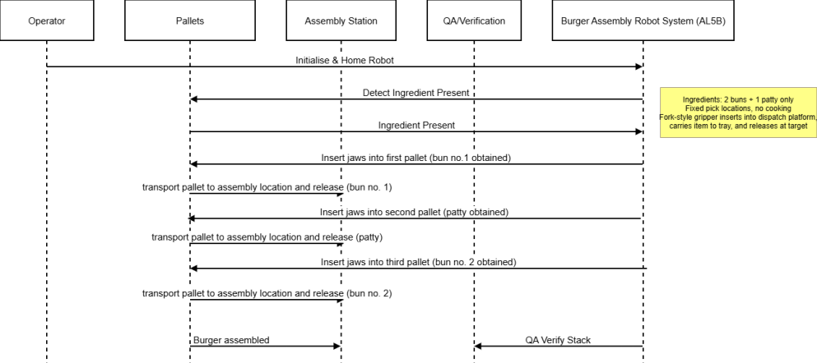

Initial Sketches (Noah)

CAD Models and Drawing (Chris )

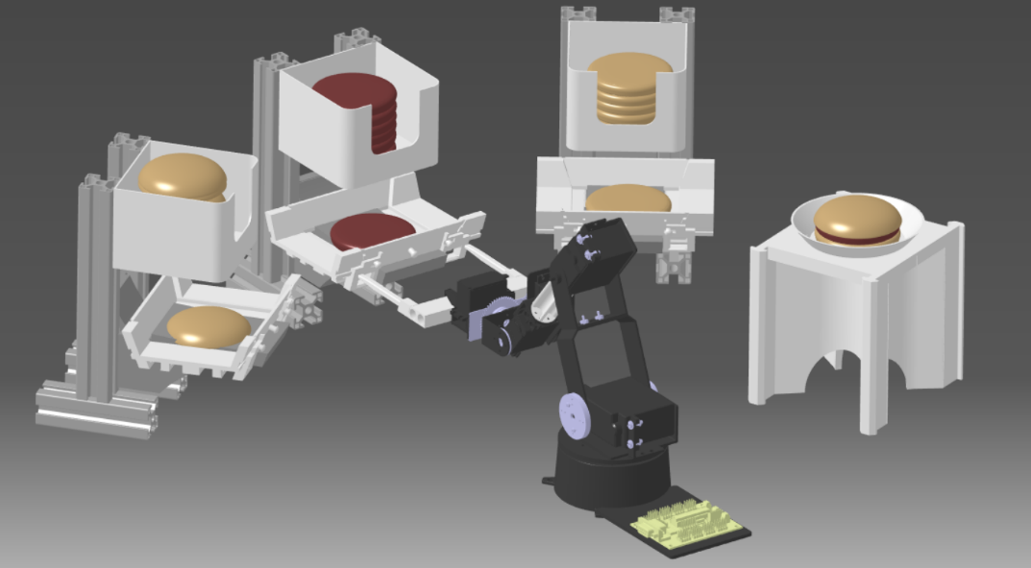

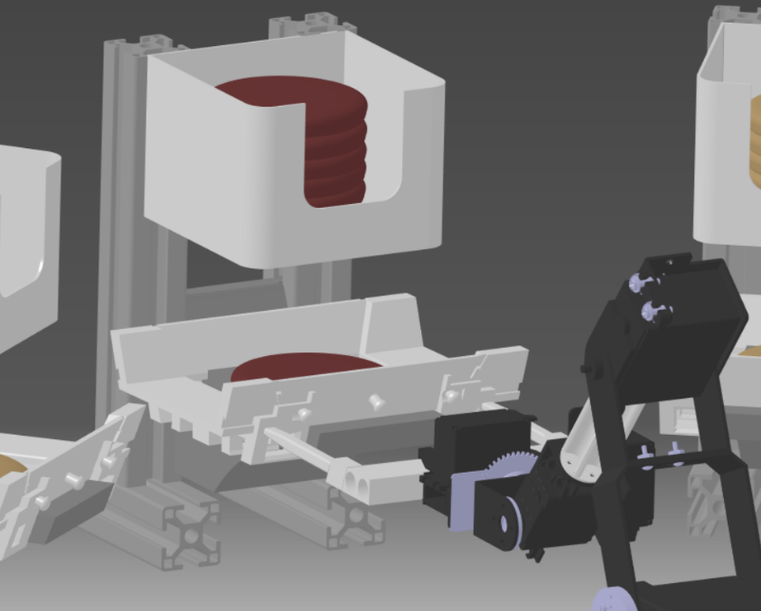

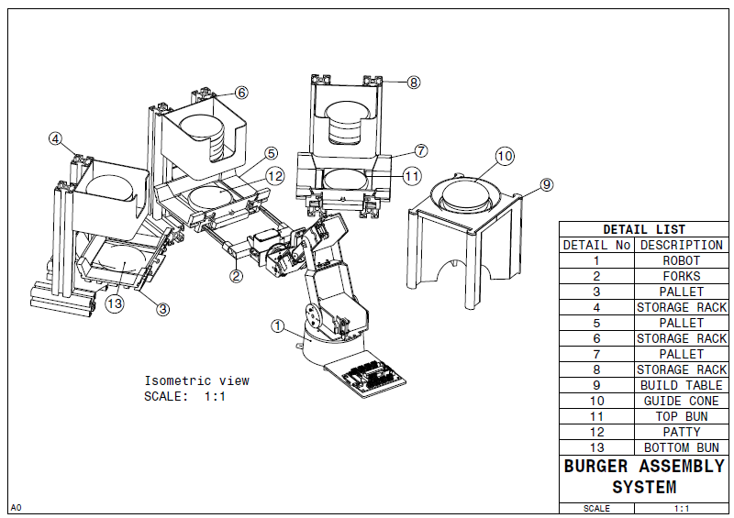

Software
The software provides the operator-facing control layer and is responsible for translating high-level intent (pick location, place location, sequence timing) into low-level servo commands. Core software responsibilities are:
Kinematic modelling (forward and inverse kinematics) to convert between Cartesian targets and joint angles.
Calibration tooling to map servo pulse widths to real joint angles and define a repeatable home/zero reference.
Teleoperation controls for incremental target updates in XY and Z, with clear target feedback.
Teach mode for building waypoint/keyframe sequences (including timing) without immediately commanding the robot.
Routine and timeline execution to combine modular movements into a complete burger assembly program.
System state management (Teach vs Live) and signalling outputs (LED states) aligned to operational state.
A key design decision was to separate 'Teach' from 'Live' execution. Because the arm is open-loop (no joint encoder feedback), safe and predictable behaviour depends on careful calibration and staged execution. The Teach environment allows sequences to be created and edited before commanding the physical robot.

Electrical
The electrical scope for the MVP focused on operator/system status indication rather than full standalone control electronics. A 6-LED scheme was implemented to communicate machine readiness, activity and mode in a manner consistent with common industrial conventions.
Three LEDs form a vertical traffic-light stack (red/amber/green) for high-visibility machine state. A second set of three LEDs (white/yellow/blue) provides operator-specific information: power-on, teach mode active, and PC/robot live synchronisation. LED meanings were aligned to conventions described in BS EN 60204-1:2018 (equipment of machines) to reduce ambiguity for users familiar with industrial automation.
Due to limited general-purpose I/O on the supplied controller board, LEDs were driven using available servo PWM output channels. This enabled required signalling without modifying the robot hardware, but introduces a visible flicker characteristic typical of PWM-driven discrete LEDs. For a productionised design, a dedicated controller with GPIO or a driver module would be preferred.

High-level Design
High-level design describes how each subsystem is organised internally, how information and actions flow between them, and how the system behaves during an assembly cycle. This level links the top-level concept to concrete implementation choices (interfaces, operating modes, and major algorithms/mechanisms).

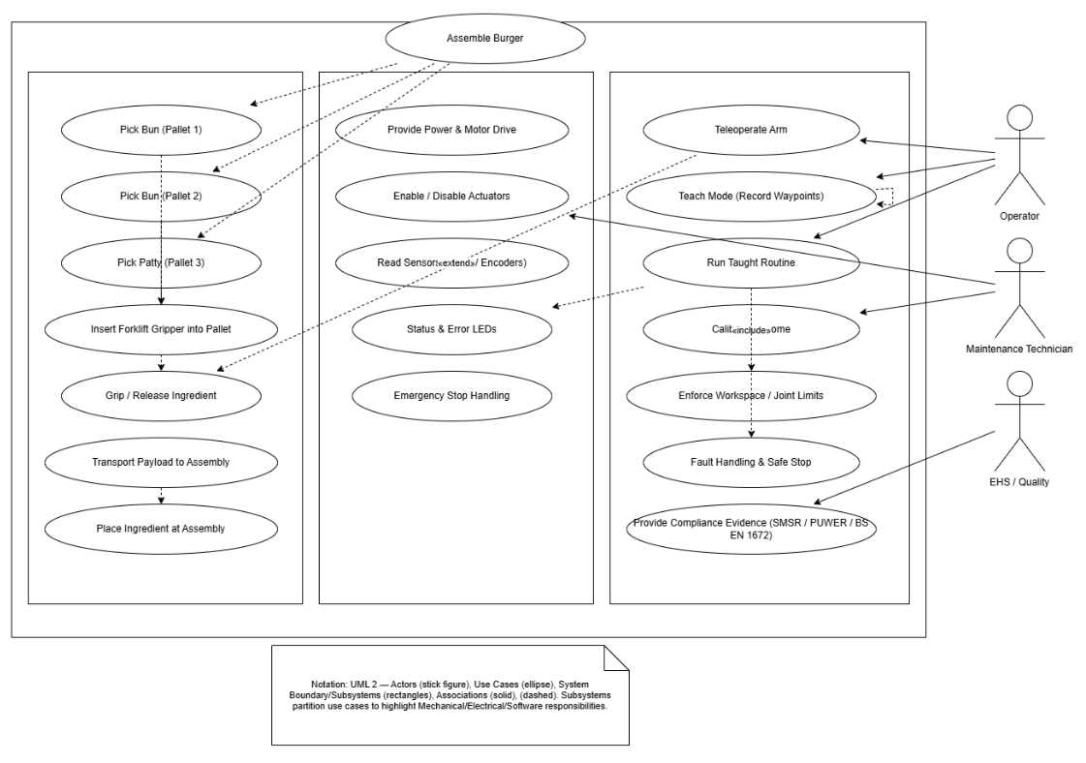Case diagram – can be removed as not sure if required if we have flowcharts for each subsystem within each high-level sub section

Mechanical
The high-level mechanical behaviour during an ingredient placement cycle is:
Robot moves to the selected station and aligns forks with the pallet entry features.
Robot pushes the pallet rearwards to clear the station retention ledge, then lifts and withdraws the pallet.
Robot moves to the assembly table drop zone and aligns pallet above the centering guide.
Forks actuate the pallet slides/jaws to open the drop aperture in a controlled, centred manner.
Ingredient drops under gravity; the guide feature corrects small lateral errors and supports consistent stacking.
Robot closes the pallet (slides return via springs), then returns it to the station behind the retention ledge.
Two key high-level design choices were used to improve repeatability: (1) passive station retention features to avoid adding actuators, and (2) self-centering behaviour in the pallet opening mechanism (stoppers and spring biasing) to mitigate asymmetric friction and ensure the drop aperture remains centred.

Sub-system Flow Chart (Case Diagram) Chris
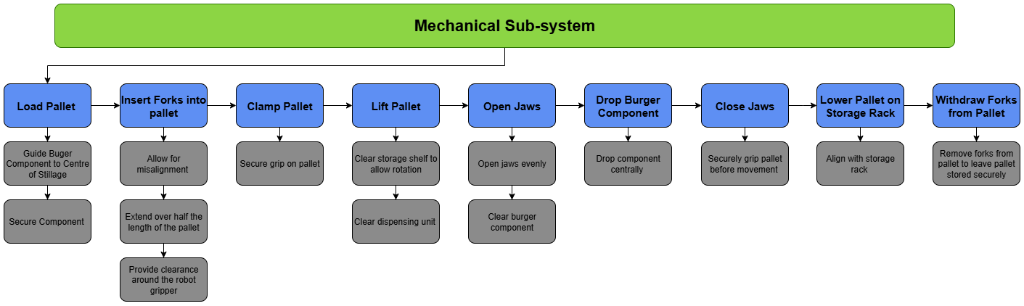
Diagram showing each stage of operation (eg, jaws in pallet, clamp pallet, pick pallet)

Software
Software high-level architecture is organised into four layers, each with clear responsibilities to support traceability and testability:
UI Layer: panels for mode selection (Teach/Live), teleop controls, calibration wizard, routine editor and timeline builder.
State/Workflow Layer: state machine that governs mode transitions, permissible actions, and LED signalling updates.
Motion Layer: kinematics, joint limit enforcement, interpolation between targets, and conversion to time-stepped servo commands.
Hardware & Persistence Layer: serial communications to the robot controller, plus JSON-based storage for calibration and saved routines.
This layered approach allowed the team to iteratively add UX features (editing keyframes, renaming, copying, deleting, scrolling for long sequences) without destabilising low-level motion code. It also simplified V&V because each layer can be tested with appropriate evidence (e.g., UI behaviour screen recordings, command logs, and physical robot demonstrations).
To address operator intuition, the teleop interface supports both global-axis movement and tool-relative movement. Tool-relative control ensures that 'forward/back' remains consistent from the operator perspective even when the arm is rotated relative to world axes.

Electrical (only required in top/high-level design)
Electrically, the additional hardware required for the prototype was limited to status indication and associated wiring. The key implementation points are:
LEDs mounted as two groups: a high-visibility red/amber/green tower and a user-facing white/yellow/blue status strip.
LEDs driven from available servo PWM channels on the controller board due to the absence of convenient GPIO outputs.
Series resistors selected for each LED (220 ohm used during prototyping, with forward-voltage and current calculations to be confirmed in the final report).
Breadboard-based prototyping with jumper-linked rails to provide common power/return connections.
LED semantics were mapped to software state: for example, teach mode illuminates yellow; live/comms status illuminates blue; and green transitions between solid (ready) and blinking (routine executing). This mapping provides an immediate, non-software-dependent visual indication of system state during demonstrations and testing.

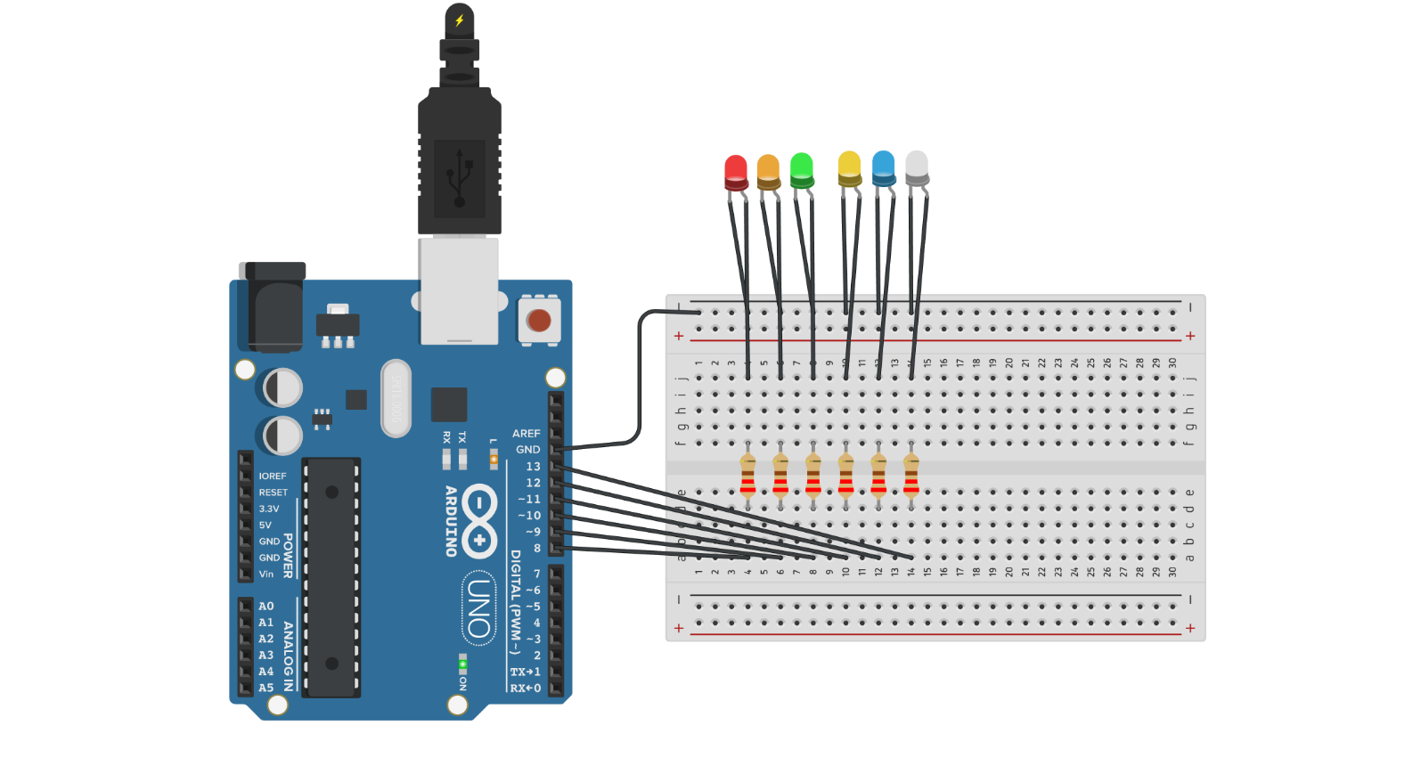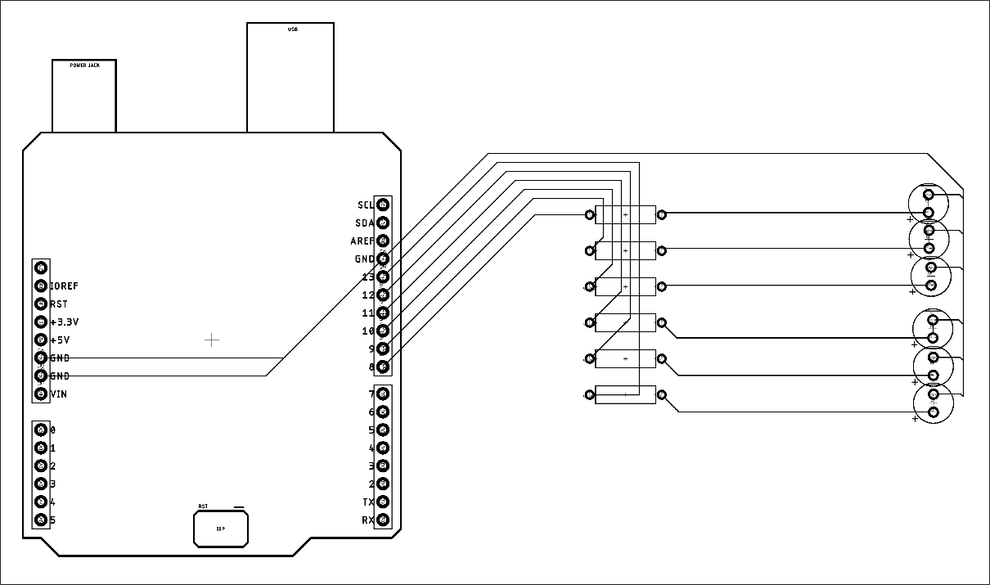
- Mention PWM used as no GPIO – causes flickering
- ISO standard but maybe this is top level?

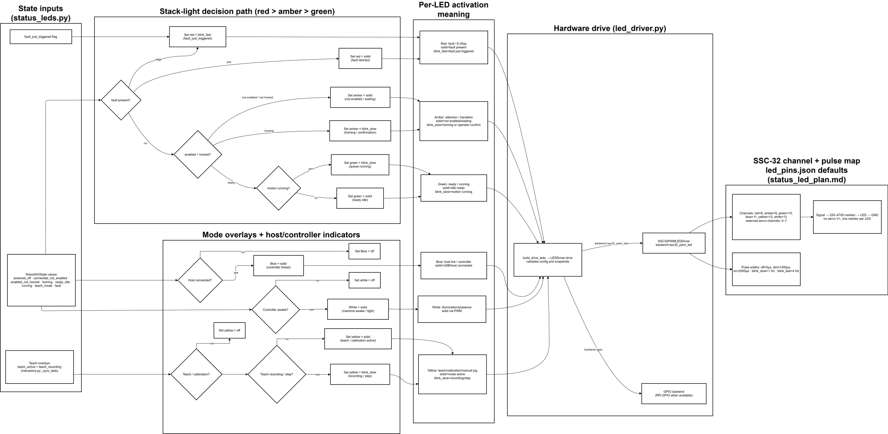

Low-level Design
Low-level design captures the detailed implementation of the key mechanical parts and the software logic required to execute repeatable pick-and-place movements. The prototype was built using rapid, iterative development; therefore, this section emphasises the design rationale, key iterations, and the final design features that enabled repeatable operation.

Mechanical

Replacement Arm
The supplied AL5B platform is payload-limited; therefore, reducing moving mass was treated as a practical performance improvement. A lightweight replacement link was designed to substitute an aluminium tube section between motor 3 and motor 4. The goal was to reduce inertia at extension while maintaining sufficient stiffness to avoid excessive deflection.

CAD Model

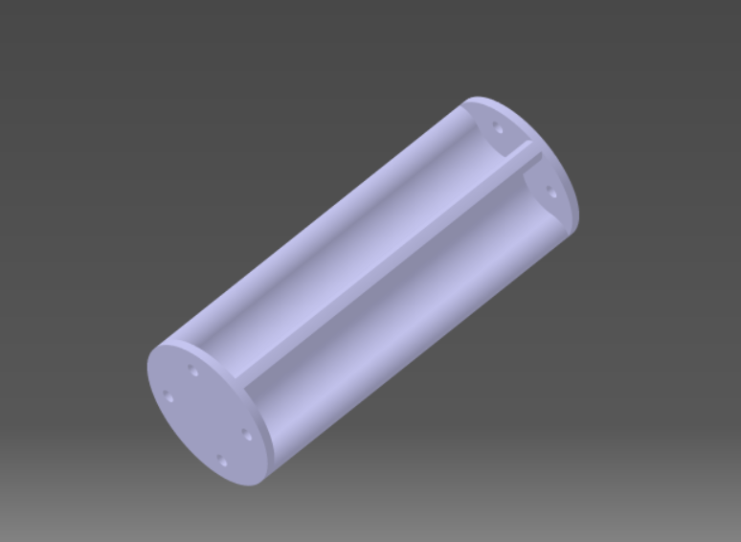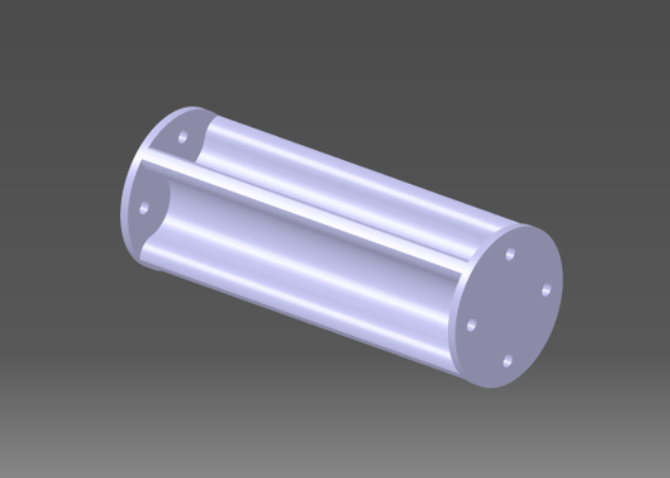

Analysis
Mass reduction was achieved by replacing the solid tube with a 3D printed part using a hollowed geometry and local reinforcement ribs. This reduced the part mass from approximately 15 g to 9 g (~40% reduction), lowering the torque demand at full extension and improving repeatability when lifting pallets. Because the arm operates open-loop, reducing load variation also reduces the chance of position drift caused by motor heating or stalling.
Print orientation was selected to avoid layer-line fracture along the primary bending direction. Where early prototypes failed along layer boundaries, later prints were oriented at an angle to distribute tensile stress across layers.

Forks

Design Development
Fork tooling was selected to provide a simple, reversible interface between the existing gripper and the pallet mechanism, analogous to a forklift. The forks bolt onto the gripper without permanent modification to the robot. Key design drivers were: (1) reliable insertion without snagging, (2) sufficient bending strength without excessive mass, and (3) an insertion depth compatible with the robot's limited working envelope.
Several iterations were produced to balance these constraints:
Thickness increased at the root to prevent snapping while maintaining a tapered leading edge.
Length adjusted to reduce slide rotation and improve contact stability, but limited so the robot could fully withdraw after actuating the pallet.
Chamfers/tapering added to improve tolerance to minor misalignment and reduce the chance of catching on pallet features.

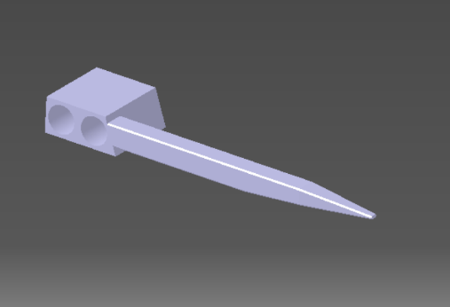
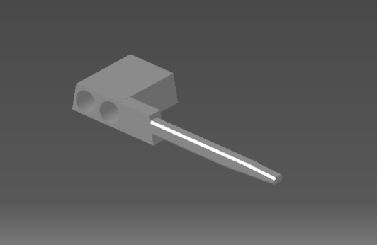
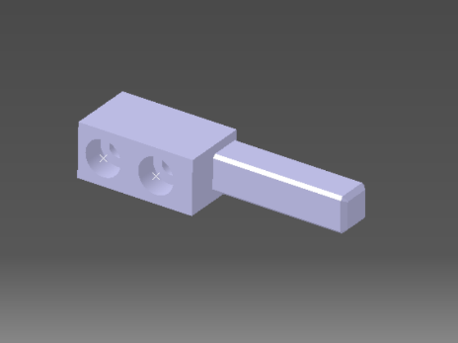
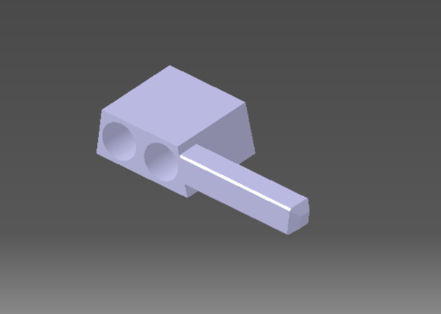
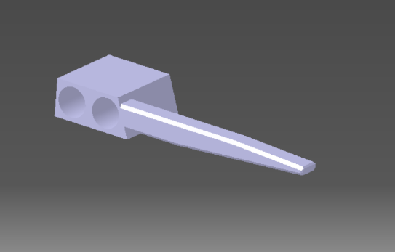



CAD Model

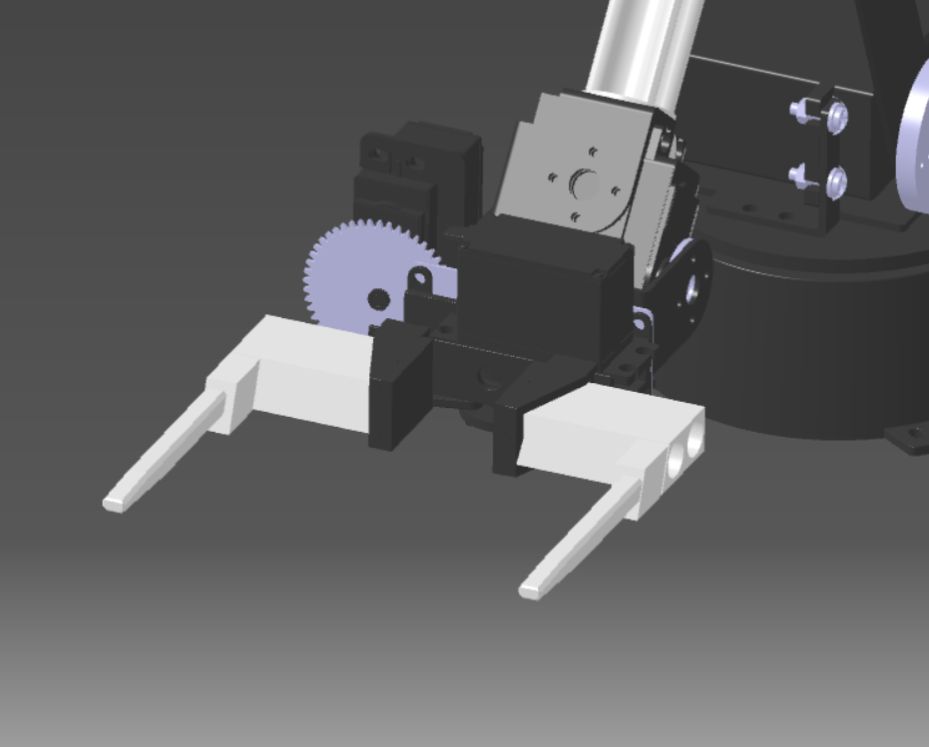

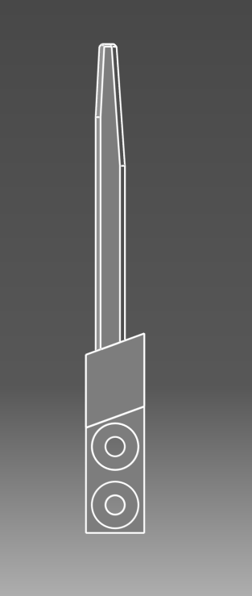

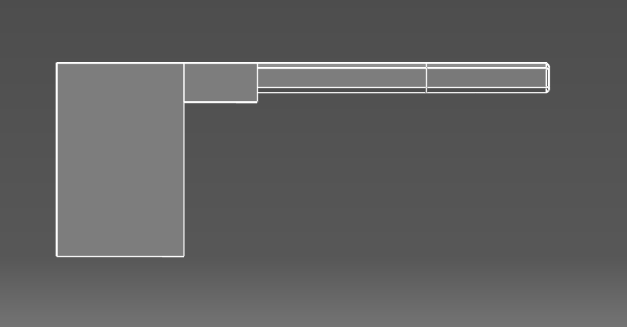

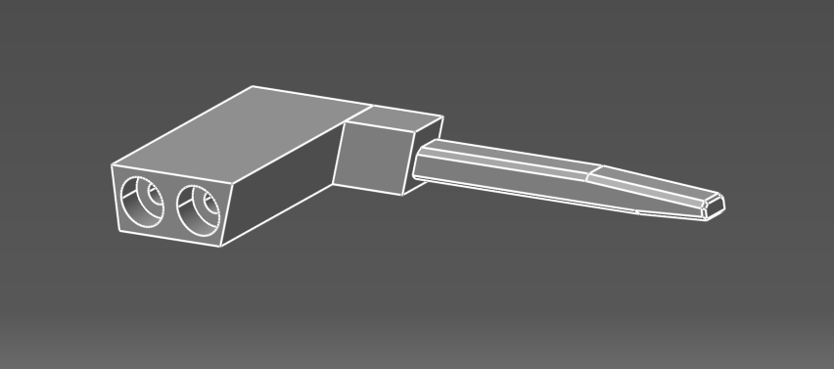

Analysis
The final fork design used local reinforcement at the gripper interface to resist bending while keeping the distal end slender for insertion. This reduced the risk of layer-line fracture and prevented the repeated snapping observed in early, overly-thinned prototypes. The fork contact surface was also modified to push closer to the centre of the pallet slides, reducing torsional loading that previously caused slide rotation and increased friction.

Pallet

Design Development
The pallet is the key enabling mechanism for repeatable ingredient placement. Early concepts that relied on rotating or tipping the ingredient out were rejected because the AL5B wrist rotation is limited (~180 degrees) and friction-based sliding was assessed as inconsistent. The selected concept uses two opposing slides/jaws that open to create a controlled drop aperture. The ingredient is supported until the opening is sufficiently wide, at which point it drops under gravity.
Development followed a rapid iteration loop: print -> test -> identify failure mode -> revise geometry. Major issues and mitigations are summarised below:
Excess mass at full extension: reduced by hollowing and thinning, then selectively re-thickening high-stress regions.
Slide friction and binding: improved by increasing stiffness, sanding contact faces, and adding lubrication (grease gave the largest improvement).
Asymmetric slide motion causing off-centre opening: mitigated using end-stops (forcing the lagging slide to catch up) and spring biasing to self-centre.
Slide rotation when over-travelling beyond rail support: mitigated by extending rail guidance and moving fork contact points toward the slide centreline.

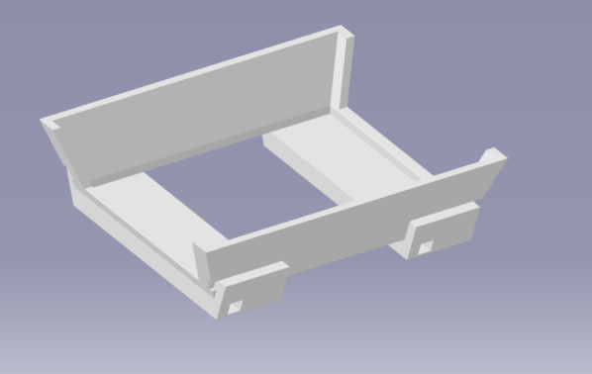
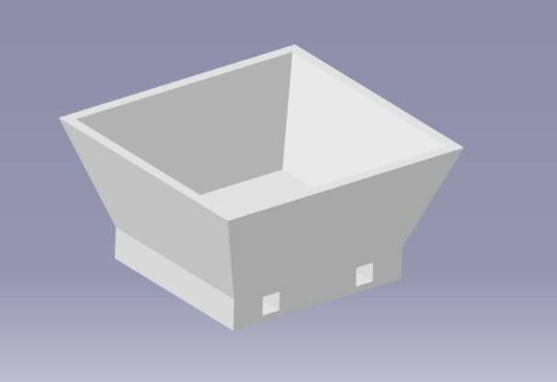
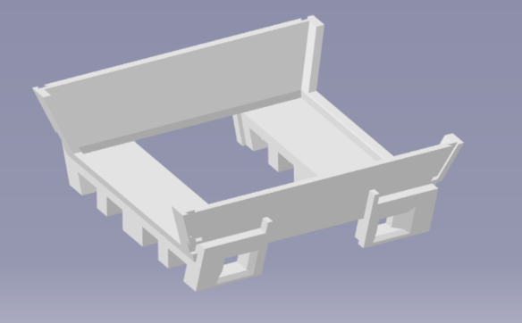
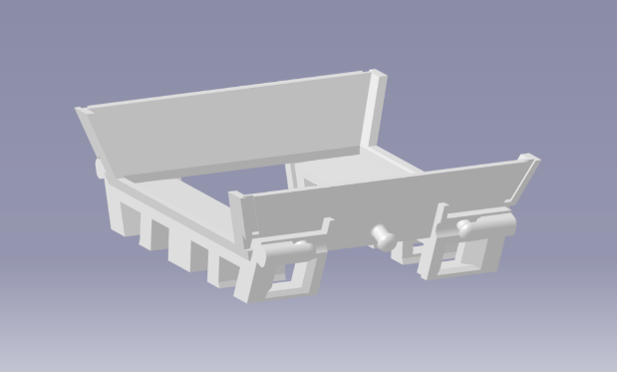
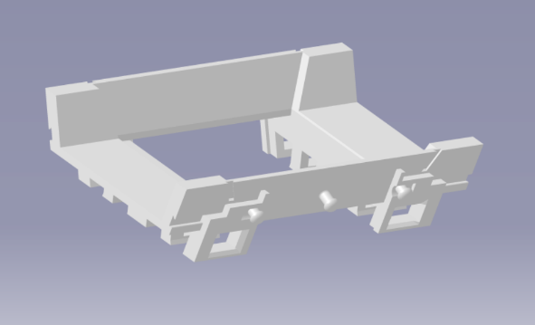
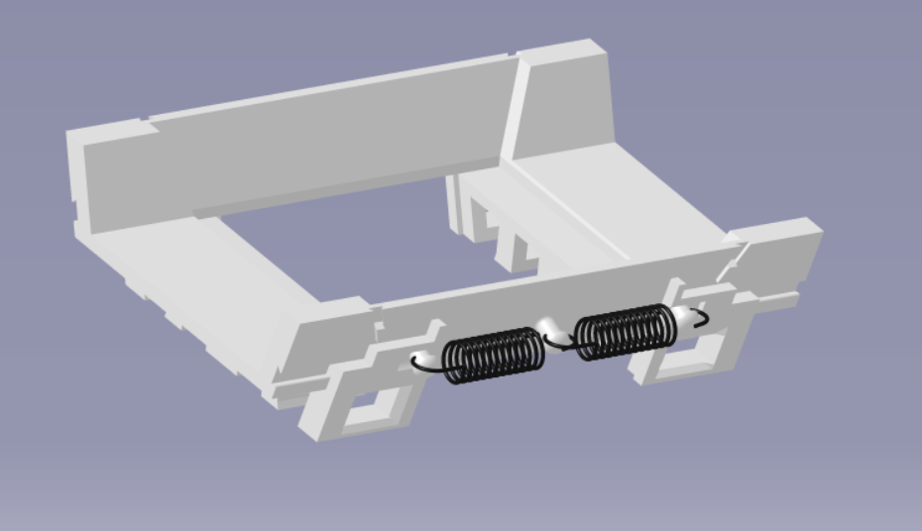

CAD Model and Drawing

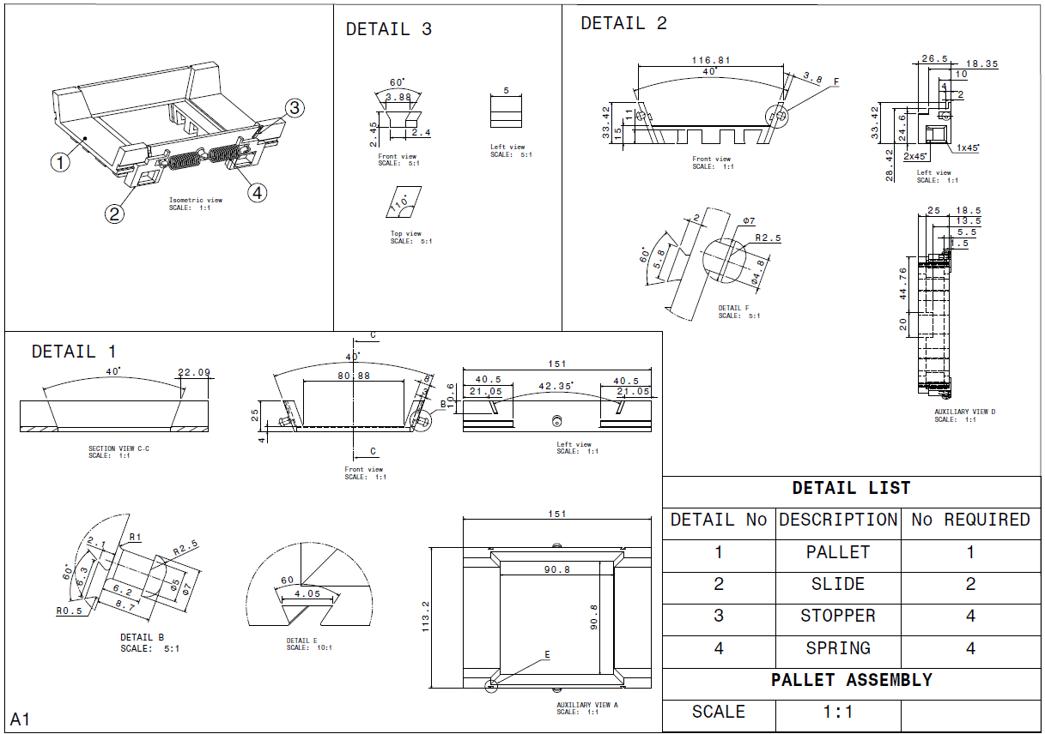

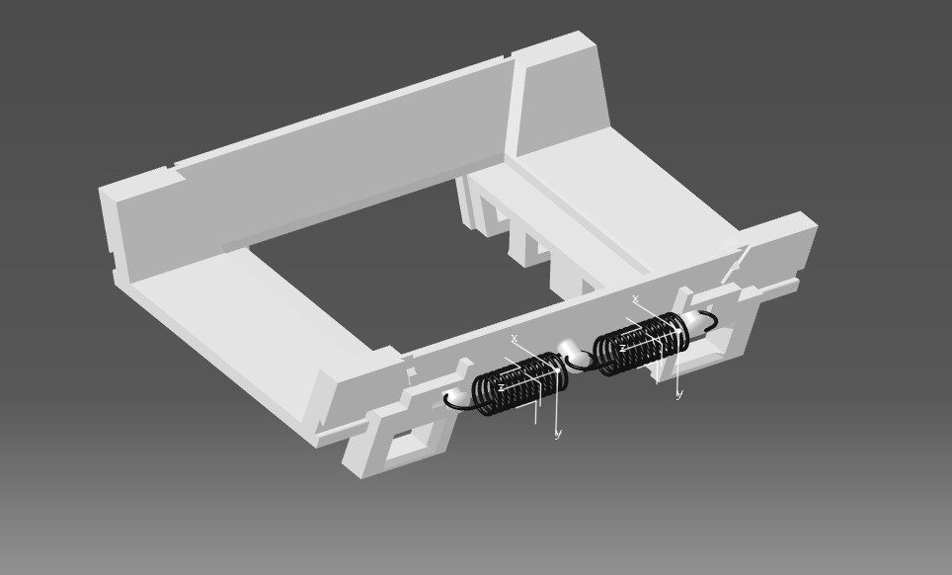

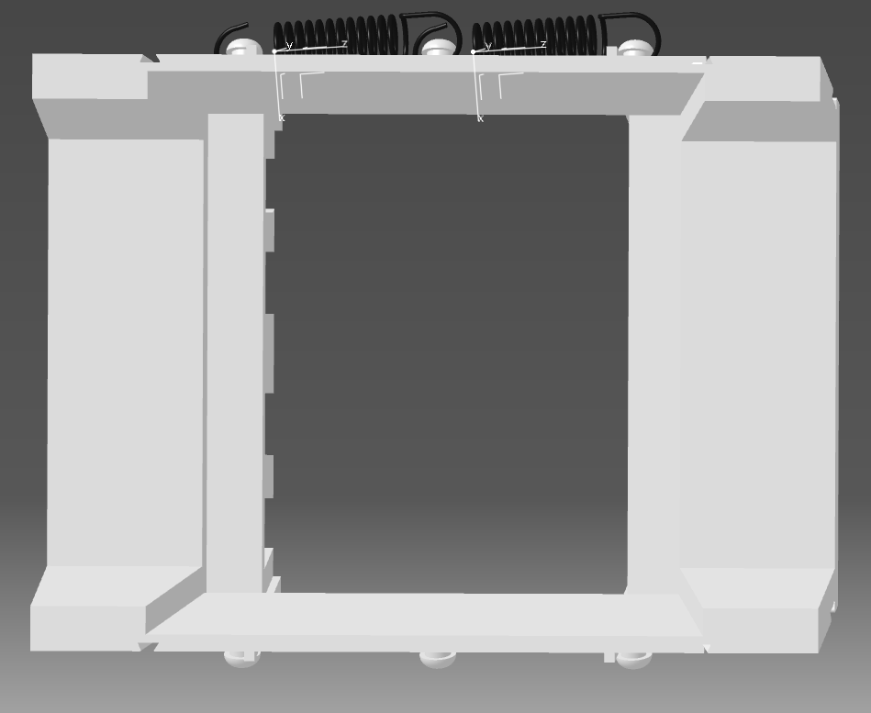

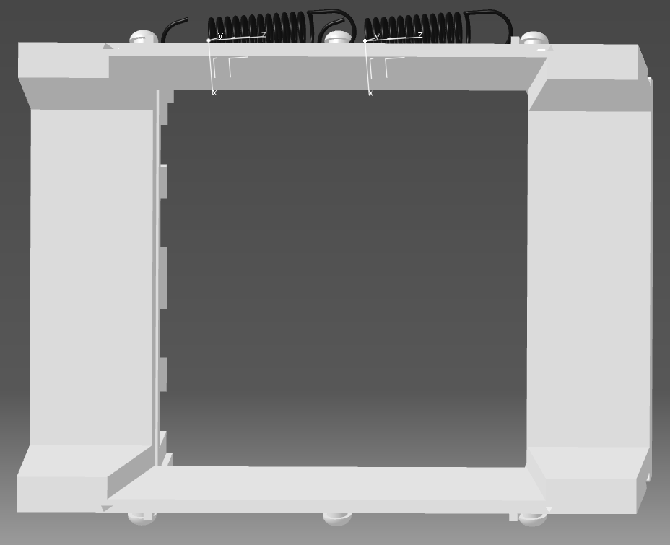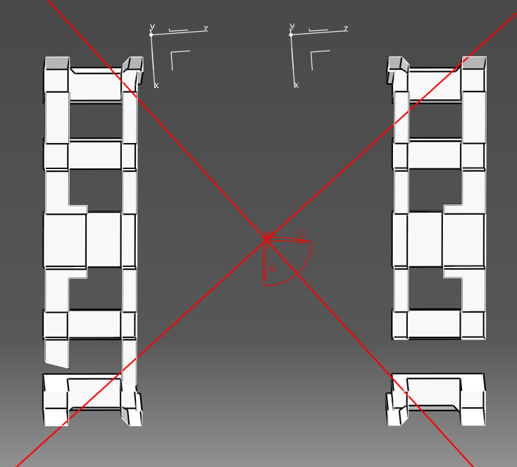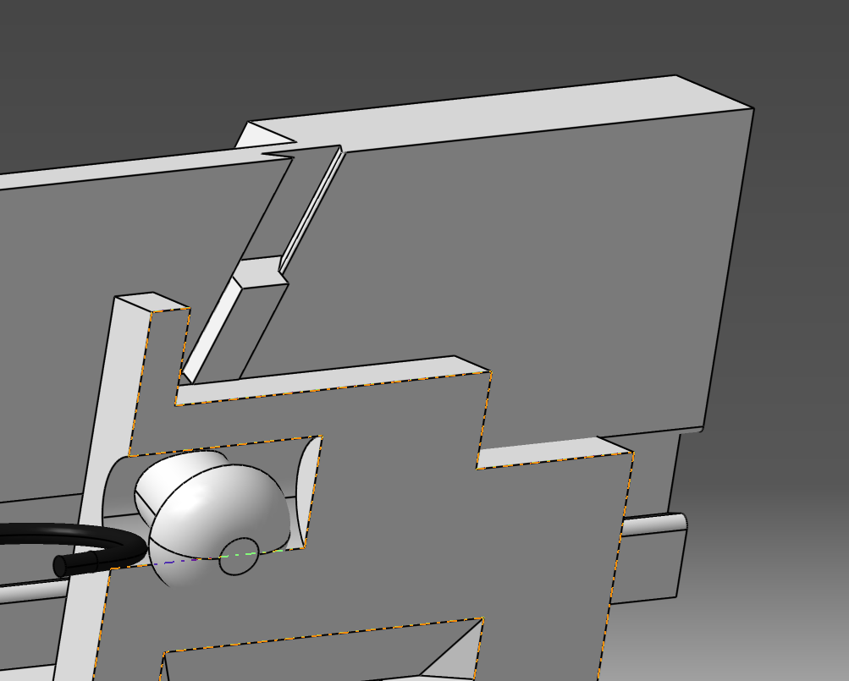

Analysis
The final pallet design combines geometric guidance, compliance, and surface finishing to achieve repeatable opening and closing. Springs provide a restoring force to close the slides and an inherent self-centering bias: if one slide moves further, its spring tension increases, encouraging the opposite slide to move and reducing the chance of an off-centre aperture. End-stops prevent one slide from fully outrunning the other.
Because the actuation force is limited by the gripper and servo torque, friction management was treated as a primary design driver. Post-processing (sanding) and lubrication reduced stick-slip behaviour and improved repeatability across repeated cycles. For productionisation, the mechanism would benefit from low-friction materials, bearings, or moulded surfaces with controlled tolerances rather than rough FDM layer lines.

Storage Rack
The storage rack provides repeatable locations for ingredient pallets while avoiding additional actuators. A passive retention ledge prevents pallets from sliding out unintentionally. To remove a pallet, the robot pushes it rearwards to clear the ledge, lifts, and then withdraws. To return a pallet, the robot pushes it back over the ledge and allows it to drop into the retained position before withdrawing the forks.

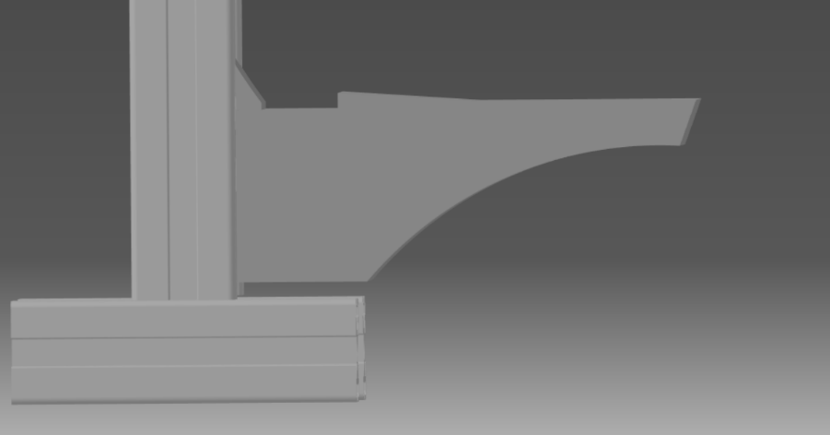
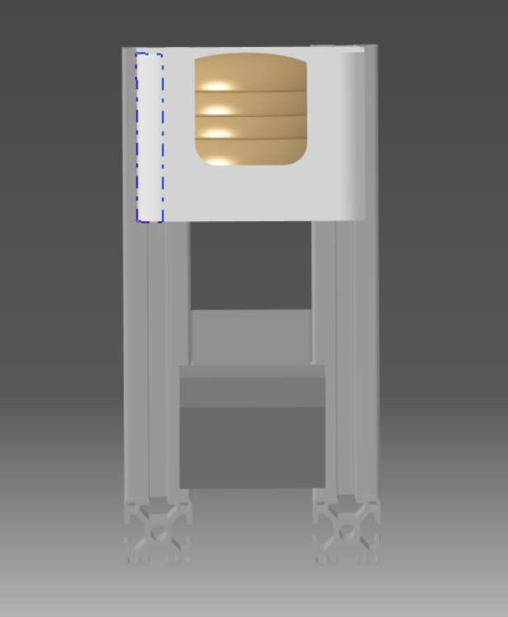
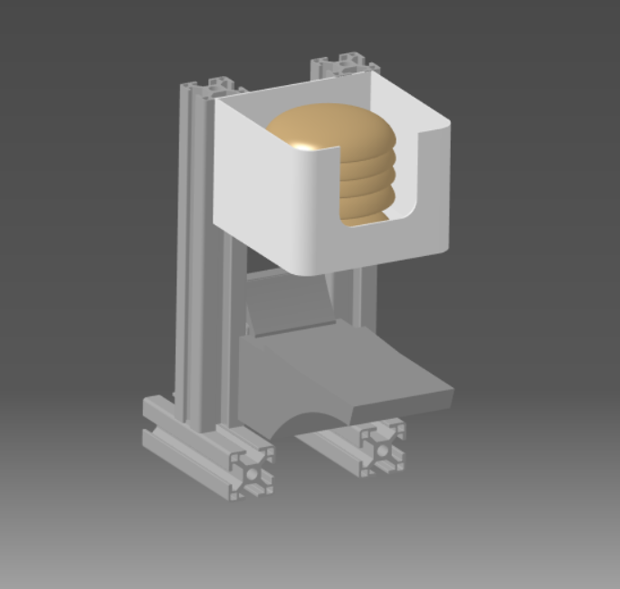
CAD Model

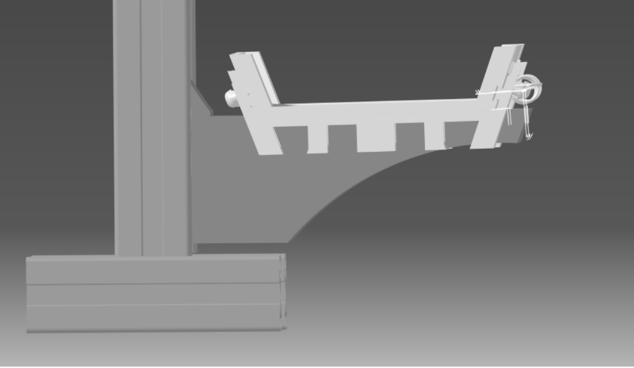

Analysis
This retention method provides a fail-safe behaviour: when forks withdraw, gravity and the ledge geometry keep the pallet seated. The approach also supports scalability because additional stations can be added by replicating rack geometry without new control signals.

Assembly Table
The assembly table defines the final drop zone for stacking. Table height was chosen to place the drop zone within a stable region of the robot workspace, reducing travel distance and minimising the impact of reach limitations. A cone-shaped centering guide was included to correct small lateral misalignments during ingredient drop and to improve the repeatability of stack alignment.

CAD Model

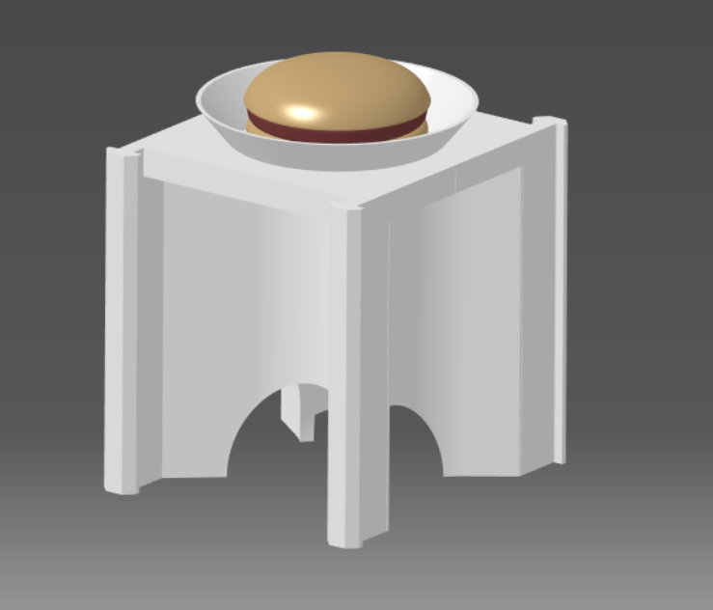

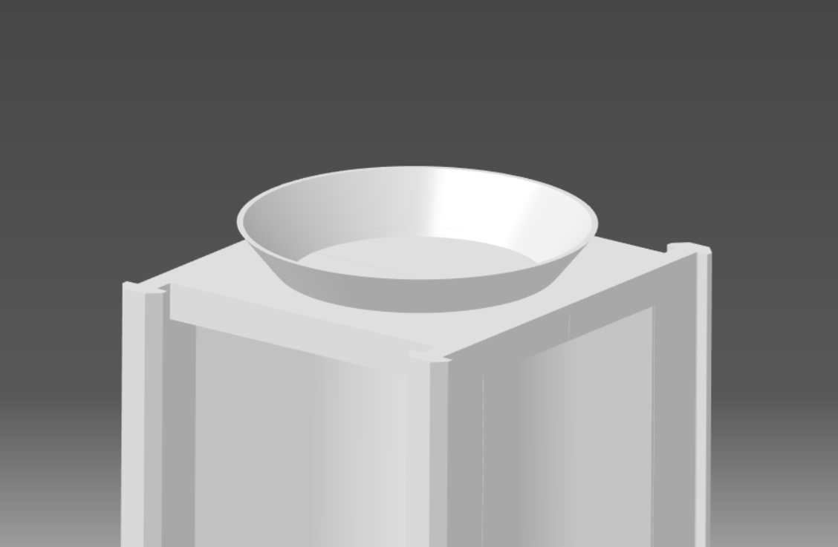

Analysis
During testing, guided dropping improved consistency compared to free drop, particularly when small positioning errors accumulated from open-loop servo control. The guide feature therefore acts as a mechanical error absorber, reducing the burden on control accuracy and improving overall system robustness.

Software
Low-level software implementation focused on enabling repeatable motion despite open-loop hardware. The final implementation can be summarised as: (1) kinematics model, (2) calibration mapping, (3) command generation and execution, and (4) teach/routine data structures.

Kinematics model
Forward kinematics (FK) is used to update the on-screen robot representation from current joint angles, providing immediate feedback for debugging and operator understanding. Inverse kinematics (IK) is used to compute joint angles required to reach a target (x, y, z) with a user-defined end-effector orientation. Targets outside of the reachable workspace are rejected and clamped via joint limit checks to prevent invalid commands.

Calibration and configuration
Each servo is calibrated by recording its minimum and maximum pulse width values alongside measured physical angles. A repeatable zero reference is then defined by aligning the arm to a clearly identifiable vertical pose and storing per-joint offsets. The calibration process is presented as a guided workflow so the operator can step through joints, record values, and validate motion direction (including optional motor inversion).
Calibration and user settings are persisted to a local JSON configuration file stored separately from the main application folder. This prevents iterative software updates from overwriting calibration and supports rapid development without losing commissioning data.

Teleoperation command generation
Teleoperation updates the target incrementally rather than commanding a single large step. Each UI action (click-to-set or nudge control) updates the target marker and triggers a fresh IK solve. The resulting joint targets are converted into smooth, time-stepped PWM commands (interpolated over the user-defined travel time) to avoid abrupt motion. A tool-relative movement option is provided so that operator forward/back commands remain intuitive when the robot is rotated relative to world axes.

Teach mode, routines and timeline execution
Teach mode builds sequences as ordered keyframes. Each keyframe stores a pose target (x, y, z, orientation) and an associated travel duration to the next frame. Operators can insert and delete individual keyframes, edit durations, copy/paste poses, and rename steps for clarity (e.g., Pick bottom bun, Move to table, Drop). Once created, sequences are saved as reusable routines that can be composed into a higher-level timeline. The timeline enables re-ordering, looping and rapid reconfiguration of the burger build sequence without re-teaching fundamental motions.
During execution, the software transitions to Live mode, validates that calibration is present, sets LED states to indicate mode and activity, and then streams interpolated servo commands to the controller. Green indication is used to show readiness vs execution (solid vs blinking), while yellow and blue are reserved for teach and live/comms states respectively.

Robustness and known limitations
Because the platform has no joint feedback, accuracy depends on calibration stability. During development, two practical issues were observed: servo heating can change behaviour over time, and hardware faults (e.g., servo failure/replacement) can masquerade as software defects. These were managed through repeated demonstration tests, recalibration checks, and by keeping configuration data separate so the system could be re-commissioned quickly after hardware changes.

Verification & Validation Planning (Noah)

V&V Strategy
Verification and Validation (V&V) were implemented from the very beginning of the requirements process and therefore from the start of the project
This ensured that each requirement was verified and validated against stakeholder expectations from the top system down to the sub-systems with enough time to introduce changes and improvement opportunities.
By fully integrating the V&V process throughout the development lifecycle the team ensured compliance to technical requirements as well as achieving stakeholder satisfaction, allowing confidence in the robot’s ability to meet its intended purpose.

Describe your overall approach for checking the system meets requirements.

Verification Methods
Our verification process involved the confirmation of correct implementation of each and every requirement through structured activities. As shown in figure ... each requirement listed has been verified against at least one verification method The different verification methods used by the team as well as example for each are as followed:
- Demonstration – an example where this method was used to verify a requirement was...
- Testing – an example where this method was used to verify a requirement was..
- Report – an example where this method was used to verify a requirement was..
- Analysis – an example where this method was used to verify a requirement was..
- Other – an example where this method was used to verify a requirement was..

These types of verification methods are detailed in [standard]. Further verifications conducted for all other requirements can be found in figure...

Explain how you will verify (inspect, test, analyse) each requirement.

Validation Methods
Our validation process involved the confirmation of implemented requirements delivering tangible value to stakeholders. This is also shown in figure … with each requirement deemed suitable for validation was validated against at least one validation method (as is the case for the verification process). The different validation methods used are as followed:
- Demonstration
- Feedback
Same as for the verification methods, all validation methods have been taken from the [standard].
Describe how users/stakeholders confirm the system meets their needs.

V&V Matrix Overview

Summarise the planned matrix linking requirements to V&V activities.

Regulatory Considerations

Identify relevant standards (ISO/CE) and how they influence V&V.

Our verification process involved the confirmation of correct implementation of each and every requirement through structured activities. Examples of some these structured activities are code reviews, simulation testing, and compliance checks. In the case of our team we confirmed that the accuracy of the robot's gripper and arm movements could be repeatably verified.

Our validation process involved the confirmation of implemented requirements delivering tangible value to stakeholders. Examples of some of the activities for this process involved demonstration of complete Burger assembly tasks performed by the robot, aligning system performance with stakeholder expectations, and gathering feedback to ensure usability, safety, and efficiency.

5. System Design
5.1 Top-Level System Architecture

Present the overall system structure and major components.

5.2 System Interfaces

Describe how subsystems communicate and interact.

5.3 Environment / Workspace Design

Show the layout and physical environment where the robot operates.

5.4 Use Case Diagrams

Show user interactions and functional scenarios.

5.5 Sequence Diagrams

Show the sequence of events between components during a task.

5.6 Flowcharts

Illustrate the high-level logic of system operation.

6. Sub-System Design & Implementation
6.1 Mechanical Design
6.1.1 Mechanical Concept Development

Describe initial design ideas, alternatives, and justification.

6.1.2 CAD Modelling

Document CAD models showing geometry and assembly.

6.1.3 Working Envelope Extension

Explain how you achieved the required 50 cm reach.

6.1.4 Custom Mechanical Modifications

Detail added or modified parts tailored to your application.

6.1.5 Gripper Design

Explain the gripper design, functionality, and reasoning.

6.1.6 Mechanical Analysis

Summarise forces, stress, spring, or structural calculations proving feasibility.

6.2 Electronics Design
6.2.1 Microcontroller Selection & Justification

Explain your choice of controller and why it's appropriate.

6.2.2 Power System

Describe how components are powered and any safety considerations.

6.2.3 Motor Driver Selection

Explain how motors are driven and why that driver was selected.

6.2.4 Sensors & Safety Features

Describe sensors used (e.g., IR) and how they improve safety.

6.2.5 Circuit Diagrams

Provide circuits for control, power, and sensors.

6.2.6 PCB (if required)

Explain custom PCB design rationale and layout.

6.3 Software Design
6.3.1 Software Architecture

Describe how the software is structured at a high level.

6.3.2 Teleoperation Mode

Explain how the user controls the robot manually.

6.3.3 Teach Mode

Describe how the robot learns and saves movements.

6.3.4 Autonomous Execution

Explain how the robot performs taught sequences automatically.

6.3.5 Safety Interlocks & IR Sensing

Explain how software uses sensors to prevent collisions.

6.3.6 Data Structures / Pseudocode / Class Diagrams

Present low-level software logic and structures.

7. Integration and Testing
7.1 Integration Strategy

Explain how mechanical, electrical, and software parts were combined.

7.2 Unit Testing

Describe tests on individual components.

7.3 Sub-system Integration Tests

Explain tests done after combining components.

7.4 Full System Functional Testing

Describe tests on the complete robot performing tasks.

7.5 User Testing / Acceptance Testing

Describe testing with real users or simulated stakeholders.

7.6 Test Logs & Evidence

Show logs, screenshots, videos, or data from testing.

8. Verification & Validation Results
8.1 Summary of Verification Activities

State what was verified and how.

8.2 Summary of Validation Activities

State what was validated with users or stakeholders.

8.3 Coverage of Requirements

Show how many requirements were fully met.

8.4 Outstanding V&V Gaps

Identify any requirements not fully verified or validated.

8.5 Discussion of System Performance

Explain how well the system meets its goals overall.

9. Intellectual Property Considerations
9.1 IP Risks

Identify existing products or patents your design might conflict with.

9.2 Patentability Assessment

Discuss whether your design has novel elements.

9.3 Freedom to Operate

Assess whether you can legally develop and sell the product.

10. Costing & Business Model Overview
10.1 Bill of Materials (BOM)

List components, quantities, and costs.

10.2 Prototype Budget Use (£75)

Show how the £75 was spent on hardware.

10.3 Estimated Manufacturing Costs

Give approximate costs if mass produced.

10.4 Business Model Feasibility

Explain how the product could be commercially viable.

11. Meeting Minutes Summary
11.1 Meeting Log Overview

Summarise key decisions made across all meetings.

11.2 Contribution Tracking

Evidence individual contributions and accountability.

12. Reflection
12.1 Personal Reflections

Each member reflects on their own performance and learning.

12.2 Team Reflection

Discuss team strengths, weaknesses, and group learning.

12.3 Lessons Learned

State key insights gained.

12.4 Future Improvements

Explain what would be done differently in a future project.

13. Conclusion

Summarise project outcomes, final performance, and how well aims were met.

14. References

List all cited sources in correct academic format.

Appendices
List/Matrix of supporting documens
Provide large supporting documents (CAD, code, logs, diagrams) not suitable for the main body.

References

Appendices

Risk Management and Safety Requirements

The risk matrix for the H&S risk assessment has been provided below.

Very likely  5 | 5 | 10 | 15 | 20 | 25
Likely  4 | 4 | 8 | 12 | 16 | 20
Possible  3 | 3 | 6 | 9 | 12 | 15
Unlikely  2 | 2 | 4 | 6 | 8 | 10
Extremely unlikely  1 | 1 | 2 | 3 | 4 | 5
Likelihood (L)  Severity (S) | Minor injury – No first aid treatment required  1 | Minor injury – Requires First Aid Treatment  2 | Injury - requires GP treatment or Hospital attendance  3 | Major Injury  4 | Fatality  5
Table 1 - H&S Risk Matrix
The risk matrix altered to align with project management risks has been provided below.

Very likely  5 | 5 | 10 | 15 | 20 | 25
Likely  4 | 4 | 8 | 12 | 16 | 20
Possible  3 | 3 | 6 | 9 | 12 | 15
Unlikely  2 | 2 | 4 | 6 | 8 | 10
Extremely unlikely  1 | 1 | 2 | 3 | 4 | 5
Likelihood (L)  Severity (S) | Negligible impact on project  1 | Minor delay or cost increase  2 | Moderate delay/cost or quality issues  3 | Major delay/cost or regulatory breach  4 | Project failure or severe legal/financial impact  5
Table 2 - PM Risk Matrix
Action level matrix is the same for both risk assessments and has been provided below.
POINTS: | RISK LEVEL: | ACTION:
1 – 2 | NEGLIGIBLE | No further action is necessary.
3 – 5 | TOLERABLE | Where possible, reduce the risk further
6 - 12 | MODERATE | Additional control measures are required
15 – 16 | HIGH | Immediate action is necessary
20 - 25 | INTOLERABLE | Stop the activity/ do not start the activity
Table 3 - Action Level Matrix

Screenshot of DFMECA document for safety requirements.
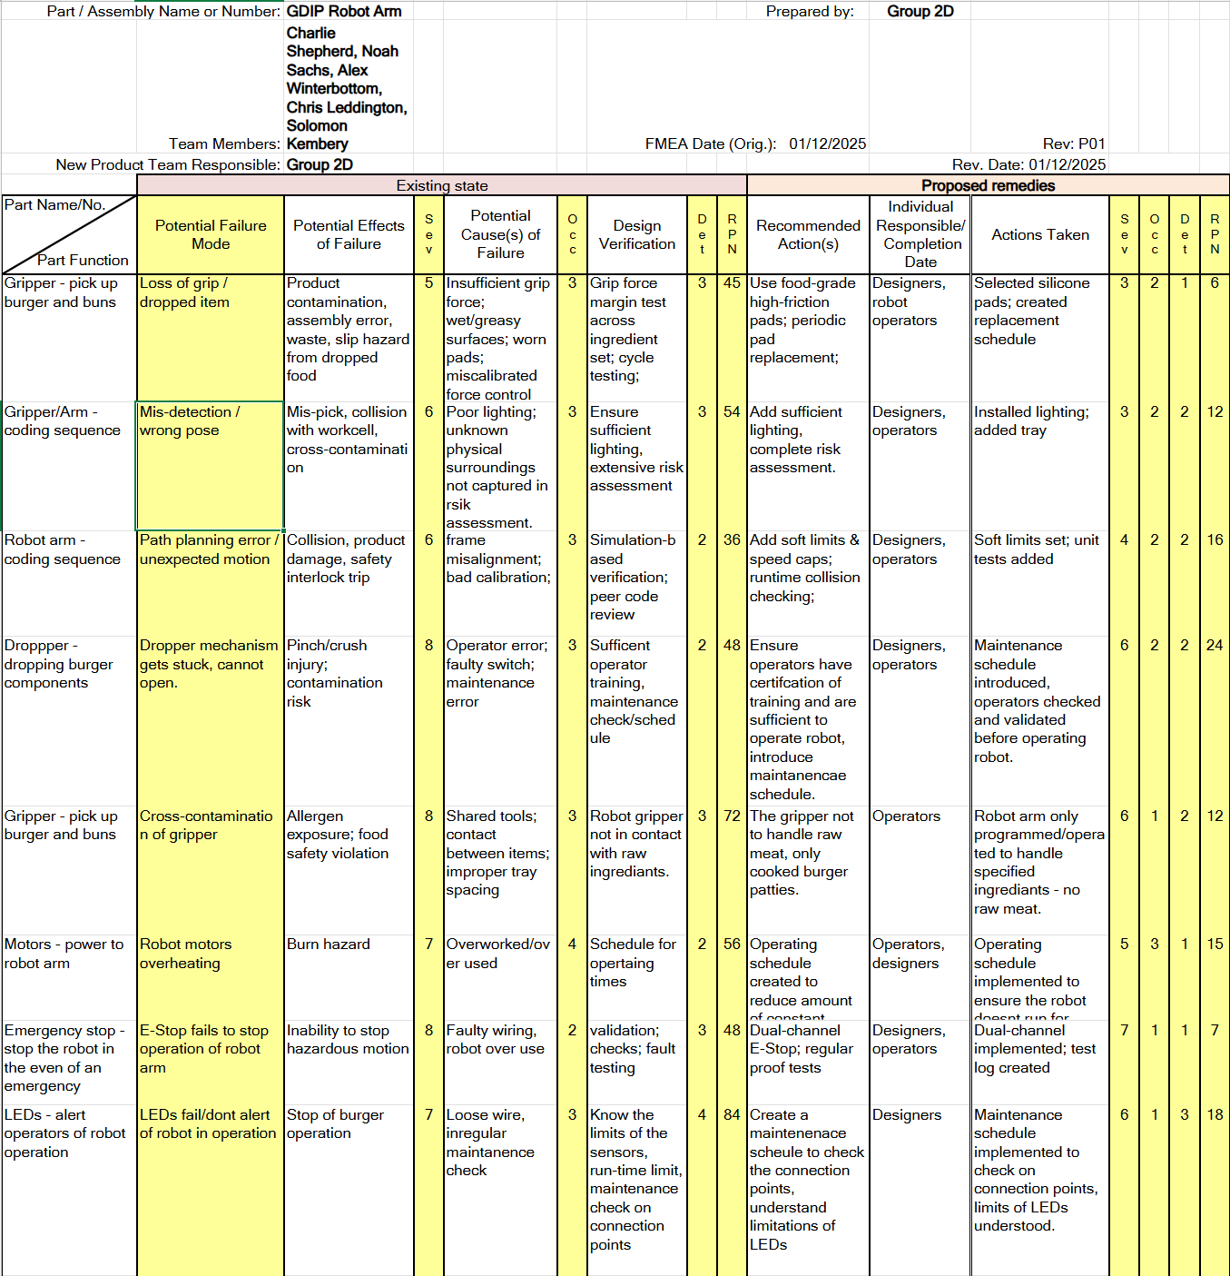
Table 4 - DFMECA

Stakeholder Analysis
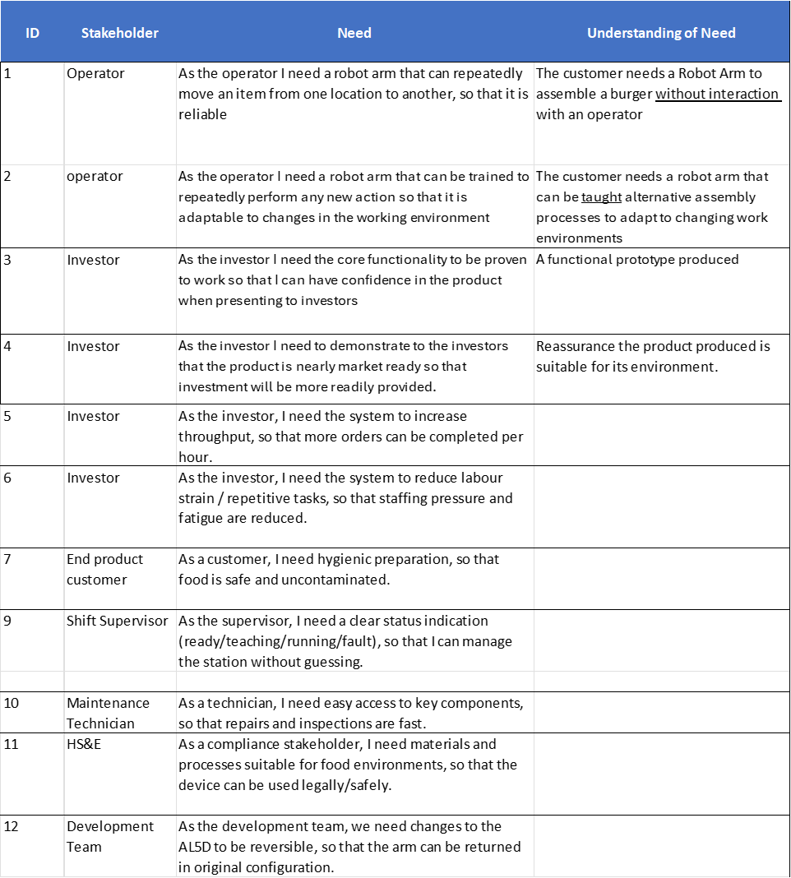

Collaboration and Communication


Figure 2 - Task Allocation

